Guidelines for contextual data collection for contaminant studies on Peregrines and other falcons

European Raptor Biomonitoring Facility

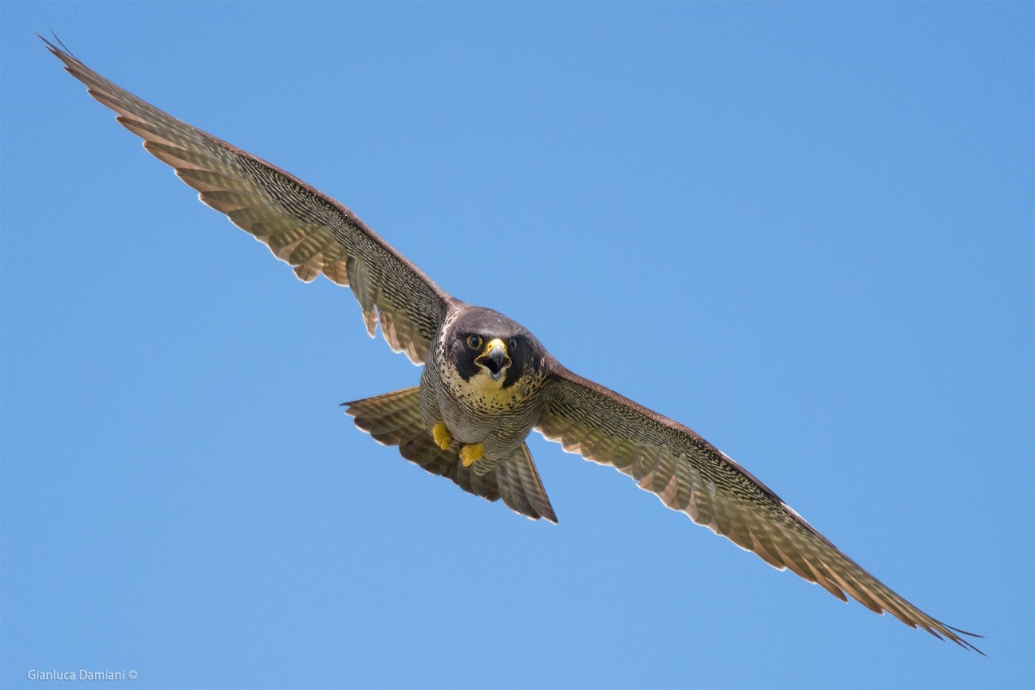

Short Term Scientific Mission
April 2019
Mission Holder:
Lucie Michel

Preface

The European Raptor Biomonitoring Facility (ERBF) aims to promote the use of Raptors for pan European contaminant monitoring. This Document is a result of a Short-Term Scientific Mission (STSM) carried out by Lucie Michel (Giessen University, Germany) within the COST program, in Rome (IT) in collaboration with the scientific Association Ornis Italica and Giacomo Dell’Omo. During the STSM raptor field Guidance and protocols were reviewed to produce species- or genus-specific best practice Guidelines for the collection of contextual data.

Content

Preface 2
1. Introduction 4
1.1 Contaminants in Peregrines 4
2. Guidelines 4
2.1 Basic contextual data 4
2.2 Observing, handling, and timing 6
2.2.1 Observing Peregrines 6
2.2.2 Handling 6
2.2.3 Timing of visits to nest sites 7
2.3 Measurements 8
2.3.1 Egg measurements 8
2.3.2 Determining chick age 10
2.3.3 Determining chick sex 12
2.4 Determining breeding parameters 13
2.5 Feather 13
2.5.1 Feather terminology 13
2.5.2 Choice of feathers 14
2.6 Prey Item determination 15
2.7 Background contextual data 16
2.7.1 Land use data 16
2.7.2 Known contamination sources 17
2.8 Dealing with public attention 18
2.9 Dealing with intentional poisoning 18
3. Conclusion 19
4. Appendix 20
4.1 Photos 20
4.3 Pre-printed data sheet 20
5. References 21
6. Links and further reading 22

1. Introduction

Contextual data add another dimension of information to a study, which allows the researchers to understand more about the sample and the background of the bird and therefore enables them to infer environmental connections and impacts of contaminants.
The genus Falco contains about 40 species which can be roughly divided into the groups of kestrels, hobbies and peregrine relatives. Peregrine falcons (Falco peregrinus) in Europe occupy different breeding habitats: some breed on cliffs, a few on trees and on ground in peat bogs, and others on man-made structures, including in towns and cities. The latter use tall buildings, pylons or other man-made structures as nest sites. These breeding habitat types exposes the falcons to different sources of contaminants through the differences in prey availability.
The decline of Peregrines because of dichlorodiphenyltrichloroethane (DDT) contamination began in the 1950 and brought them to the border of extinction in several areas. The eggshell thinning caused by exposure to the DDT metabolite diphenyldichloroethylene (DDE) was recorded first in peregrine eggs (Ratcliffe 1967, Peakall 2011). Today, peregrine populations have recovered in most of their original areas and have expanded into new, urban habitats. Urban Peregrines can be a good model species for pan European contaminant studies because (1) they are distributed all over Europe, although urban nesting may be scarce in Scandinavia and more expressed on man-made structures in open areas, (2) their vicinity to human settlements makes them useful indicators for urban living quality, (3) many nests are easy to access and observe, especially with an existing webcam network, (4) they are very popular in the public and can act as flag species to promote conservation and citizen science, (5) Peregrines in general are top predators, preying exclusively on resident and/or migrating birds and (6) their ecology is well known, which is important to adequately interpret contaminant levels.

2. Guidelines

2.1 Basic contextual data
This type of data is necessary for the identification, assignment and interpretation of any sample that is obtained. It must accompany any type of sample and should be taken as detailed as possible

Contextual data are all the information that contributes to the interpretation of contaminant analyses and are important for ecotoxicologists to draw conclusions for conservation and contaminant regulations. Although possibly appearing self-evident to the collector, this type of data is very difficult, if not impossible, to reconstruct once it has been lost or left out. It should be routinely collected and incorporated naturally into sampling procedures. The following table (Table 1) suggests the minimum elements of basic data in harmonized formats.

Table 1 Basic contextual data sampling recommendations and examples
Basic contextual data type | Context and Recommendation | Example
Date and Time | YEAR/MONTH/DAY 24:00 | 2019/03/19 11:00
Location | Exact GPS location (decimal degrees), accompanied with location description preferred. In some cases, exact nest site positions are not supposed to be revealed, then only descriptive location with closest village/municipality can be sufficient. | Karslruhe, City Centre 49.006847, 8.410892
Name of collector | Name and surname of the collector and contacts. If the collector wishes to stay anonymous, can be indicated by an abbreviation or alias to designate the samples. Consistency of spelling facilitates database enquiries. | Peter Müller (PeMü)
Raptor species | Raptor species, scientific name and common name, preferably using the nomenclature from “Handbook of birds of the world” (Del Hoyo et al., 1992-2013). If possible, also identify subspecies. | Peregrine Falcon (Falco peregrinus peregrinus), Falper
Condition (dead/alive) | Condition of the sampled individual (dead/alive), is of great importance, especially for feathers or non-invasively sampled tissues (like preen oil or integument) and needs to be indicated. If dead, mention if fresh or decomposed, also the degree of decomposition is of importance. | dead, fresh
Sample matrix | Indicating the type of sample collected is essential, mention type of matrix, tissue or organ. Also, note down number of samples best with a short explanatory ID. | Brain-Falper-TH8822-20190319_2 (Matrix-Species-Ring number-date_sample number)
Ring number | Report the ring number is useful to discover siblings from the same nest in sample collections. | TH 8822

2.2 Observing, handling, and timing
Observations are important to confirm nest site occupancy and breeding activity and status, which is the primary information for contaminant studies.

2.2.1 Observing Peregrines
Field observation of breeding activities are, when done with the right caution, the least invasive information source about Peregrines. They can give insight about nest occupancy, the identity of the breeding pair and breeding success (for definitions of ‘occupancy’, breeding success’ and other terms, see Franke et al. 2017). When monitoring the number of occupied nests in a study area there is risk of missing some nests and obtain biased data. Therefore, several site visits per year and, searching for new nest sites should always be part of field observations (see specific recommendations on surveying Peregrines in Hardey et al. 2009).
Generally, the safe distance (i.e. the distance before the falcons may be scared away or alter behaviour) suggested for peregrine observation in natural habitats is at least 500 m from the nest site. Safe distance for peregrines in urban environments may be smaller because birds are more habituated to humans. Urban Peregrines can react with increased attention and agitation to fieldworkers entering zones not usually accessed by people, such as restricted areas, towers, rooftops, etc. The sensitivity to disturbance depends also on the personality.
The number of recommended visits varies depending on the aim of the observation. Occupancy controls require at least two visits, one during the pre-breeding in March or early April, when displaying adults can be observed, and another one later to confirm occupation of the nest. Returning after hatching in late May until mid-June to look for chicks and food delivering parents can give an evidence for breeding success. A final visit in mid-June or early July can confirm the fledging success of the young, since they stay in proximity to their nest for about two months after they fledge. More detailed guidance can be found in the freely downloadable Book chapter of Hardey et al. 2009.

2.2.2 Handling
Correct capture and handling can reduce the stress for Falcons during sampling and decrease the risk of injuries! Timing should be adjusted to guarantee least disturbance throughout sensitive phases.
Eggs
When a nest can be accessed, special care must be dedicated to the handling of eggs and chicks. The egg must be handled with particular care. The embryo is developing in a fluid environment which is not rigidly attached to any kind of supporting structure. Blood vessels or membranes can get damaged if the egg is moved roughly. When handling the egg, movements should be smooth and when they are transported, they have to be safely cushioned.

Adult falcons and chicks
Most Falconiformes are unlikely to inflict major damage if handled correctly. The danger is probably greater to the bird through injury or stress during the catching and restraining process. Capturing adults is quite difficult and usually not necessary and therefore to be avoided. Nevertheless, it can occur to be confronted with an adult at the nest or in its’ proximity and it can be necessary to handle it when indications of bad health, injury or contamination are suspected. The following steps explain how to approach, capture and fix a Peregrine to avoid unfavourable stress situations:
- When approaching the nest site of and incubating or rearing parent it is important to make oneself noticed earlier by speaking louder and making noises. This is to prevent that the peregrine flushes from the nest hastily and potentially harms the eggs or pushes the chicks out of the nest.
- When capturing adults or older chicks, the feet should be restrained first, as they are most potentially dangerous, then the wings should be gently folded close to the body. Feathers must not be damaged or creased during handling.
- When holding the feet of the bird, one finger of the hand should be put between the legs so that any pressure can be felt on the finger and thus avoid too much pressure which can hurt the bird.
- Birds should be held either upright, on their fronts, or on their sides. They should not be held on their backs, unless specifically required by the manipulation (i.e. bleeding from wing).
- Keep the head covered; a Falconry Hood can be used if handling takes more than 10 minutes. There are several types of hoods with different size for males and females. As there is always the risk that the bird might escape the hood can become a danger for the bird, if it can´t be removed easily. Therefore, it is advisable to use a black sock or a similar tissue that can fall off in case of emergency.
- Handling of young chicks: Chick should never be hold at a wing or a leg but be kept with both hands by gently folding the wings and the legs on the body.

2.2.3 Timing of visits to nest sites
Timing of visits to nest sites should not coincide with sensitive times for Falcons, in which disturbance is likely to cause desertion of the nest. Such sensitives times are in general, around egg laying, which can last several days since eggs are laid with an interval of 2 days. Laying can occur from mid-February to early May, as it is influenced by latitude, altitude or continental or maritime climates. For example, laying dates are delayed about one month in northern Europe compared to southern Europe. Even within the same area laying can be shifted by 1 or 2 weeks due to weather conditions or individual decisions. Incubation starts when the last or second last egg has been laid and takes between 29-33 days/egg (Cramp & Simmons 1980, Ratcliffe 1993). In the first 8 to 10 days after hatching the chicks are brooded mainly by the female because they are more vulnerable to temperature changes. When incubation has started and during chick rearing the birds are unlikely to abandon their nest, nevertheless it is advisable to minimize the duration of the visit and approach the nest in good weather conditions with mild temperatures. Fledging initiates when chicks are 5 to 6 weeks old. For an overview of the Peregrine breeding schedule and recommended timing for nest visits see Hardey et al. (2009).
Other sensitive times can be in adverse weather conditions, since these can cause additional energetic strains to the clutch or the brood. On cold, wet or hot days, or with direct hot sunlight on eggs/small chicks, the visit to the nest should be rescheduled for better weather conditions. Timing of the day should be scheduled in the less important hours of provisioning which usually are from noon to afternoon. Most provisioning takes place early in the morning (starting at dawn) and in the evening (Ratcliffe, 1993).
The optimal timing of visiting the nests to sample chicks needs to be early enough to prevent them from jumping from the nest and late enough to ensure they are more robust to cope with being left alone by the parent and to take accurate measurement to determine age/sex. It has been suggested this is the case when chicks are between 16 and 25 days old. Match timing of sampling with ringing chicks.

2.3 Measurements
Body measurements ensure essential baseline data to calculate and compare age and sex and determine the health status of the Falcon.
There are priority measurements that can be used to estimate chick sex and age as well as incubation time (for eggs). These are listed and explained in Table 2 whereas the high priority measurements are written in bold. A picture guide is attached in the Appendix. Numerous brilliant and detailed guides exist and are listed in appendix for further reading.

2.3.1 Egg measurements
If there is lacking information about laying date, egg measurements can give an estimation of the covered incubation time and remaining incubation time. Eggs begin to lose weight (i.e. water) as soon as they are laid. From 18 % (Rahn & Ar 1974) to 16% (Hoyt 1979) of the fresh egg weight (FEW) is lost, in general, from the time of laying to the time of hatching. The ratio of egg length and width together with an observed weight coefficient can be used to calculate FEW. Knowing the FEW and the actual weight can therefore be used to estimate remaining incubation time.

The following formulas have been provided by Burnham´s guidelines for artificial incubation of Peregrine eggs (1983).
$$W=K_{w } \left(LB²\right)$$
where $W$ = fresh weight (g)
$K_{w }$ = observed weight coefficient for peregrine eggs (0,0005474) (Burnham 1983)
$L$ = Length of egg (mm)
$B$ = breadth of egg (mm)
This calculated FEW can bear errors by as much as 2%, however, this does not affect much the estimation of the hatchability of healthy eggs. Although this formula has been worked out for Peregrines, it seems to work well for other species.
To further calculate the days of incubation that have been already covered the Formula can be used
$$I_{d}=\frac{W-X}{\frac{0,141 W}{31, 5}}$$
where $I_{d}$= days of incubation
$W$= fresh egg weight
$X$ = egg weight at time measurement
$0,141$ = factor for 10 or approximately less days of incubation
$0,147$ = adjust factor for eggs that have been probably incubated for over 10 days
$31, 5$ = number of days of incubation to pip for peregrines

An easy tool to estimate incubation time for Peregrine eggs by inserting egg length, width and mass can be found on the website vandrefalk.dk/egg.
Some chicks are very vocal close to pipping and whilst still in the egg. Sometimes movement can be seen as the embryos start to get active, others make no sound or movement until the pipping process has begun. Other sources use calibration curve with egg density (egg mass divided by volume) to estimate hatching date (Hardey et al. 2009). This method requires repeated visits to weigh the eggs and is therefore not very suitable for this protocol.
The functions available are estimations abstracted from different Peregrine populations. However, incubation times can vary among Peregrine populations (Cramp & Simmons 1980). For example, Peregrines in Rome have an average incubation time of 37 days, in Colorado and New Mexico 31.5 days (Burnham 1983). Therefore, these formulas provide approximate values only.
Table 2 Overview of measurements and how they should be measured
Measurement | How to measure it? | Source
Chicks
Weight | Measured with a spring balance. Chick is placed into a cotton bag and hooked to the spring balance. Weight can be read when the bag is hanging freely and equilibrated (weight of the bag alone must be subtracted from it). | Hardey et al., 2009
Wing length (wing chord and flattened wing) | Wing chord is measured as a straight line between the wrist joint and the tip of the 8th primary laid, not flattened or straightened along a stainless-steel butted rule. Also take the maximum flattened wing length. | Hurley et al., 2007, respectively Lowe, 1989
Tarsus length | Measured from the posterior notch between the tibia–fibula and the tarso-metatarsus to the anterior notch between the tarsometatarsus and third toe joint. Done by gently holding the tibia and tarsus in a right angle and holding the metatarsi flexed in a right angle. | Hurley et al., 2007
Head-Bill length | Measured from the tip of the upper mandible to the rear of the occipital condyles at the rear and base of the skull. | Hurley et al., 2007
Tip-Cere length | Measured from the front of the cere to the tip of the upper mandible. | Hurley et al., 2007
Eggs
Egg mass | Preferably weighed to the nearest of 0.1 g using a portable electronic scale, which should be placed on an even and stable surface for accurate measurement. | Hardey et al., 2009
Egg width and length | Measured with a calliper, holding the egg between index finger and thumb and closing the two jaws carefully around the tip and the bottom of the egg (length) and the equator of the egg (width); for width, rotate the egg and record the maximum value. Before removing the calliper, it should be opened to not scratch or crack the eggshell while removing it (plastic callipers are safest). | Hardey et al., 2009

2.3.2 Determining chick age
Picture guides documenting the development stages of falcon chicks are good references to determine the chick age (see references). The following table (Table 3) aims to give an overview of some developmental key traits that can give information on the age.
Table 3 Overview of typical traits that indicate chick age
Day | Trait
1 | Eyes still closed or slit like, often moist, unfluffy down.
2-5 | Eyes more open, down dry and fluffy, able to sit in upright position, no sign of second down (SD).
6-9 | SD becomes visible at dorsal side of the wing and later at the belly and backbone
10-14 | Sheaths of primaries, coverts and tail feathers are growing, SD becomes denser and individual feathers are no longer visible.
15-20 | Sits mostly upright and is alert, contour feathers begin to grow, primaries have broken their sheaths.
20-30 | Chicks alternate increasingly between resting on their tarsi and standing on their feet. Legs are about to fully develop, by day 30 they appear half downy and half feathered, and faces are fully covered with feathers.
31-37 | Chicks start to actively preen themselves to lose their down, they become more active and vocalizing and start flapping their wing to strengthen the flight muscles, at day 37 they are fully developed and ready to fledge.

From day 13 to 21 the tail feathers are growing notably and very fast: 2 mm per day. Between 17 and 24 days is a good age for ringing because the legs are fully developed but the chicks are still quite attached to their nest and don´t tend to jump out in panic. A formula to age the chicks that has proven to work with good accuracy has been published by White et al. (2002).
$$A_{d}=\frac{Wl+0,84}{0,69}$$
where $A_{d}$= Age in days
$Wl$= Wing length (cm)

2.3.3 Determining chick sex
Many chicks can be sexed by the age of 16 days, because by that time the morphometric differences in size (females larger than males) are already big enough to distinguish them relatively safe. A study from Australia (Hurley et al. 2007) developed a more precise formula that allows sex determination in Peregrines with 98.6% accuracy by morphometrical measurements as soon as the wing length is over 9 cm (which is reached at the age of 14.3 days by applying the age formula from White et al. 2002). The morphometric measurements used in the model were wing chord ($\log_{10}$, cm), weight ($\log_{10}$, g), tarsus length (mm), head plus bill length (mm) and tip–cere length (mm).
$$D_{i}=39,930-16,830\log_{10}\left(wing chord,cm\right)+12,128\log_{10}\left(mass, g\right)+0,124\left(head-bill length, mm\right)+0,130\left(tarsus length, mm\right)+0,502(tip-cere, mm)$$
Birds with a $D_{i}$greater than zero are females and those with a $D_{i}$ below zero are males.

2.4 Determining breeding parameters
Breeding parameters can be used to evaluate performance during incubation and chick rearing. Contaminants can act upon each of those different stages.
Nesting phenology can inform about pair and territory quality and can be influenced by weather and prey availability during the pre-breeding and breeding phase. Temporal important parameters are laying date, hatching date and date of fledging. Parameters related with productivity are clutch size, hatching success, and fledging success. Clutch size can vary between 2 to 6 eggs but mostly contain 3 to 4 eggs and is an evidence for primary breeding productivity. Hatching success is secondary productivity, giving indications about the fertility of eggs and incubation performance of the adults. Overall breeding success of an individual pair is measured by counting successful fledglings. Table 4 gives an example for the simple calculation of these parameters. Contaminants can cause eggshell thinning or infertile eggs; they can impair the nest attachment of the adult during breeding or constrain the parental provisioning. Understanding which of these phases is disturbed can lead to improved knowledge of contaminant effects.

Table 4 Example for the calculation of success parameters
Breeding  parameter | Observed number | Primary  productivity (%) | Secondary  productivity (%) | Individual breeding  success (%)
Clutch size | 4 | 100 |  | 50
Hatching success | 3 |  | 75
Fledging success | 2 |  |  | 66

2.5 Feathers
Which feather samples are required is determined by the analytical techniques used and the study objectives. The following chapter aims to provide clarification about terminology and sensitise for the specifics of feather sample collection.
Knowing molting patterns and feather designation is important because depending on study design and the type of contaminant under investigation different sampling and storing techniques can be required.

2.5.1 Feather terminology
Contour feather are the basic feathers of the body and wings and include large flight feathers of the wing and tail and also smaller feathers that cover the body surface. They are comprised out of a central shaft and web or vane. The part of the shaft that is attached to the body is called calamus or quill. A detailed figure of the structure of a primary feather is provided in the review of García-Fernández et al 2013.
Wing feathers, also called remiges, are divided into 10 primary feathers (P1-10), 11 secondary feathers (S1-S11) and 3-4 inner secondaries (or tertiaries) (S12-S14/15). On the under and upper side of the wing the primaries and secondaries are covered with shorter feathers, so called wing coverts. The primaries and secondaries (and their respective coverts) are counted from the meeting point between primaries and secondaries – so the outermost primary in front of the wing tip becomes nr 10. The 12 tail feathers (rectrices) are counted from the innermost central feather pair T1 to the outermost T6 (Fig 1).

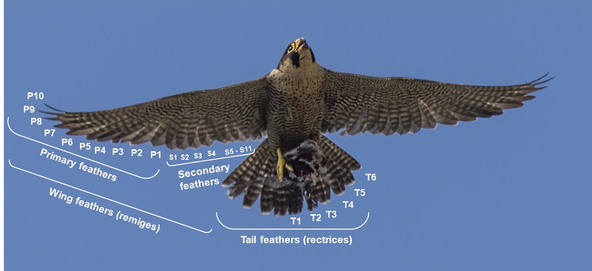
Figure 1 Location and terminology of wing and tail feathers (Photo: Gianluca Damiani)

2.5.2 Moulting strategy and choice of feathers
Adult Peregrines molt their primaries completely once a year, beginning around the time of incubation start; end of moult varies across populations, but generally will be completed by November (Cramp and Simmons 1980). Sedentary and partial migrants molt in a continuous, single season molt cycle, while long distance migrating Peregrines interrupt their molt during migration and finish it in their wintering grounds (Zuberogoitia et al. 2018). Wing molt proceeds from the centre in both proximal and distal directions during two simultaneous replacement waves. It starts with primary 4 and 5, in females when they begin incubating, so these feathers will be rebuilt while the female is at the breeding site; i.e. samples of moulted 4th and 5th primaries will represent contaminant concentrations in the blood circulation at the time of their growth the previous year. Secondaries are molted in a similar sequence, starting in the centre with S5-6-7 and then subsequently moving outwards and inwards (S4-8-3-9-2-10-11) (Miller 1941, Mebs 1960). Tail feathers molt sequence starts at the innermost remiges T1-2-3 and often jumps towards the most distal feather and progresses T6-4-5 (Mebs 1960). Adult Peregrines are, depending on their distribution, migratory or sedentary, which influences their suitablilty for studies on local contamination. Chicks, on the other hand, can be relatively good indicators of local contamination (Movalli et al. 2008) because concentrations of contaminants in the first plumage of nestlings are generally unaffected by molting and migration (Odsjö et al. 2004). Molted feathers can be found in or under the nest site and are most commonly breast and chest feathers. The size difference between males and females are also reflected in their feathers, making it possible to assign the feathers to the sexes. However, utility of molted feathers might be restricted, when it’s not known from which individual they are from and when they were grown.

2.6 Prey Item determination
Peregrines feed almost exclusively on birds. Peregrines in cities mainly prey on urban resident birds but also on migrating birds. By determining the origin of the prey, ecotoxicologists can gather more information about contamination sources. Peregrine diet can be monitored examining remains of prey items which can be found in or under the nest or on roost sites in vicinity to the nest or regurgitated pellets. Prey remains can be for example feathers, wings, skulls, legs or corpses. Using pellets is of limited value though, since they contain mostly damaged feathers, which are often difficult to identify (Drewitt 2014). Also, pellets are not very distinctive for Peregrines, meaning that they could have been regurgitated from another bird of prey. For a complete picture of the diet, it is suggested to recover prey remains below the nest regularly within a radius of 50 to 100 m and keep record of the species. Typically, removed bird heads with opened cranium can be attributed to peregrines, since they feed on the nutritious brain and discard the leftover head. The leg bones are often left attached to the pelvis and the keel bone may be notched, with pieces removed as the peregrine feeds. Peregrine pluck the feathers of their prey and these feathers can be a good indication to determine prey species. If the tip of the quill is dark from dried blood and the feather webbing is torn where the bill of the peregrine gripped and pulled or the feather is bent or broken it’s a sign that they have been plucked. Plucked feathers may also be splattered with blood and clumped together. Typically, Peregrines bring their prey to high places and use many different perches to pluck their prey. Most easy parts to assign prey species are heads, wing and tail feathers, but also other body feathers can be used. Picture guides for identification of body remains are valuable references and some book suggestions are attached in the Appendix. In the following section some handy tips for collection of prey remains are summarized:
Identifying prey remains gives an insight in the peregrines diet. Knowing the diet can help to discover contaminant sources.
- Systematically search the ground around the nesting site within a radius of 100 m
- Wearing gloves is advisable
- Collect all items that are found to (1) determine number of prey individuals and (2) to be able to distinguish new prey remains from the ones that have already been recorded
- Label all items with collection date, nest site indication, collector
- Feathers can be stored in labelled plastic bags in room temperature, heads and whole carcasses or body parts can be stored in sealed plastic bags in the freezer. Legs and wings can be air-dried when fleshy parts are removed before. For long term storage better to include an antiparasitic substance in the bag
- Primary and tail feathers, rings and wing bones can help to identify number of individual birds
- Museums, books or websites can be consulted for feather identification.

2.7 Background contextual data
Background information can help ecotoxicologists, which contaminants to look for in a specific sample. It can contribute to the choice of study design and facilitate the explanation of results.
Breeding pair history and population development in context with contamination data can reveal long-term and large-scale impacts of contamination. Especially if there are observations for recurrent abnormalities in reproduction, dispersal or behaviours it can be desirable to mention them.

2.7.1 Land use data
Data about breeding environment are highly desired to accompany the sample because they can give exclusive insight into origins and effects, networks and patterns of contaminants in falcons. Land use can in some cases easily be determined but requires a basic knowledge and interest of the fieldworker about agricultural practices and botany. Since this is not taken for granted for everybody, the following list contains useful information that help classify the land use.
- description of nest site surrounding e.g. urban settlement, industrial area, agricultural area
- description of percentual land cover (within 1 km of nest site): forest, pasture, field, aquatic surface
- rating of intensity of farming. To keep it simple, 3 categories from 1 = extensive over 2 = intermediate to 3 = intensive would make sense.
Table 5 Criteria to rate land use intensity
Signs for intensive land use are | Signs for extensive land use are
dense road network | diverse landscape
monotypic landscape, clean open fields | high degree of biodiversity
intensive use of machines and fertilizer | high degree of manual work
intensive use of herbicides and pesticides | low use of fertilizers
monoculture of high-performance varieties, high degree of specialisation | cultivation of traditional, old varieties
many drains or irrigation to control water management

- Statements about crop type. Examples are:
  - wheat or other highly bred Poaceae (also maize belongs to this group)
  - spelt and other more traditional varieties of Poaceae
  - Rapeseed or Sugarcane
  - other (Wine, Orchards, Vegetables, Tabaco…)
In all cases, photos of the surroundings of a nest site can be a great help to give a general impression of the land use and the progression of the crop when sampling took place because this is even with access to public land use data not possible. The photo should capture the relevant surrounding scenery (Fig 2), therefore a shot from nest site view is an optimal position. If crop type can´t be determined a close-up on the plants, showing leaves and flowers can be attached to the data sheet that accompanies the sample.
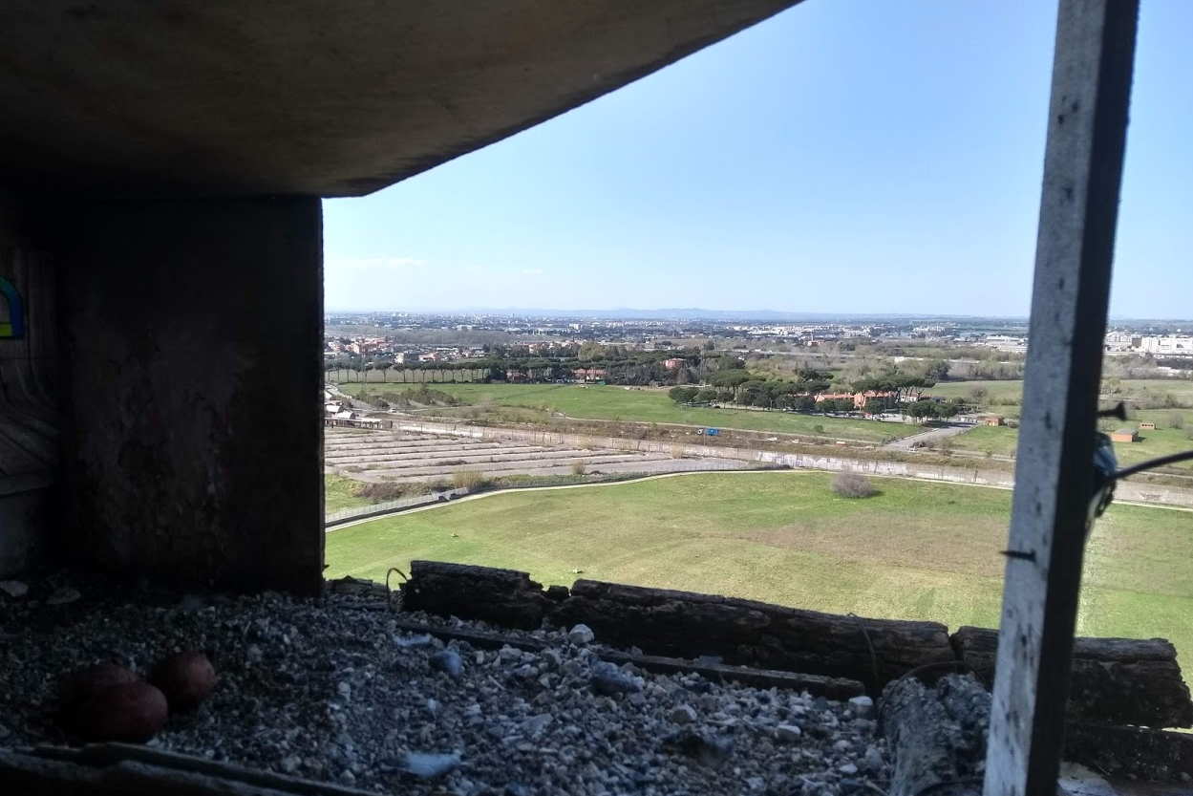
Figure 2 Overview of scenery surrounding a Peregrine nest in an industrial/urban habitat with wide open (grass) plains.

2.7.2 Known contamination sources
If the fieldworker can complete his sample with personal knowledge about contamination sources in sampling area it would very desirable. Often researchers that receive the samples don´t know much about the situation of contamination of an area and any personal observations or commonly known activities can be useful. Indicated should be:
- known present/historical point pollution sources like industrial, agricultural or mining activities
- known pronounced hunting activities (shooting of migratory birds, waterfowl hunts, etc.)
- known applications of pigeon/bird control (usually used in urban environments and in cultivations of fruits and wine)
- known pesticides in use

2.8 Dealing with public attention
In some cases, Peregrines nests are equipped with webcams and often there is a big community of viewers following the breeding activities. This is an optimal possibility to obtain reliable contextual data, since many eyes document the natural breeding progress as well as irregularities. Activities at the nest will not go unwatched and to avoid complications with the public it should be communicated in advance that a visit to nest is planned. It should be considered to remove the chicks out of the sight of the camera to ring and measure them since to public eyes some practices might look cruel. An important point is to adhere strictly to all legal requirements and make sure licenses and permits are up to date and near at hand. The fieldworker should update himself about recent changes in legal regulations before sampling.

2.9 Dealing with intentional poisoning
Several cases of intentional poisoning have been reported where pigeon breeders poisoned back feathers of pigeons with carbamates. When plucking the poisoned prey, the neurotoxic compound enters the body orally and leads to instant death. Poisoned Peregrines seem disoriented and unbalanced, falling over and not getting up on their own anymore. If a dead or impaired bird is found in the nest, it should be looked out for the potential poisoned prey, in most cases bred pigeons. Before touching the prey, gloves should be put on for individual protection. It is also useful to take pictures of the situation and note date and time of the finding. The poisoned Peregrine should be brought to a vet as fast as possible if it´s still alive. The prey remains should be collected in sealed plastic bags for forensics and labelled with a warning that there is a suspicion of poisoning. The police has to be informed to proceed with the investigation. Chick and eggs, if viable, should be collected and placed in other nests (if possible) or in incubator followed by placement of the chicks in other natural nests. Detailed guides for hand breeding and rearing Peregrines can be found in the appendix.

3. Conclusion
Correct and consistent labelling of the samples is one essential requirement for the fieldworker since any sample is useless without clear designation. Generally, it is preferred to collect data by observations rather than by visiting the nest. Alongside with that, webcams provide a unique possibility to observe all breeding parameters thoroughly without any disturbance. It also allows minimizing the nest visit to just one visit at ringing. At this visit all necessary samples and information about the chicks (measurements, prey item collection, eggshell fragments) can be taken. When sampling feathers, the fieldworker should be familiar with the terminology of the feathers, preferably cut or pluck body contour feathers and choose the right packaging and storage methods for the designated analysis. Detailed info can be found in the sampling protocol from Espín et al. 2014. Collection of prey items is especially important in poisoning cases. Attached photos and additional background information about land use, breeding site and breeding pair history can deliver crucial information for the completeness of the contaminant study. It is advisable to make use of the pre-printed data sheet that can be found in the appendix to make sure contextual data is complete. Intentional poisoning are crimes that threat the life and reproductivity of Peregrines. Even when the intentional killing has been confirmed and the crime is investigated, it can be difficult to find the responsible person. The correct securing of evidence can be key for convicting the criminal. For peregrine fieldworkers it is therefore desired to be familiar with signs for poisoning, how to react and who to inform when there is suspicion of intentional killing. Any suspicion should also be mentioned in the contextual information that accompanies the sample.

4. Appendix

4.1 Photos
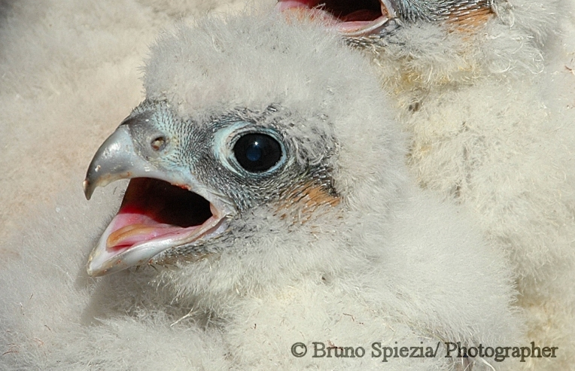
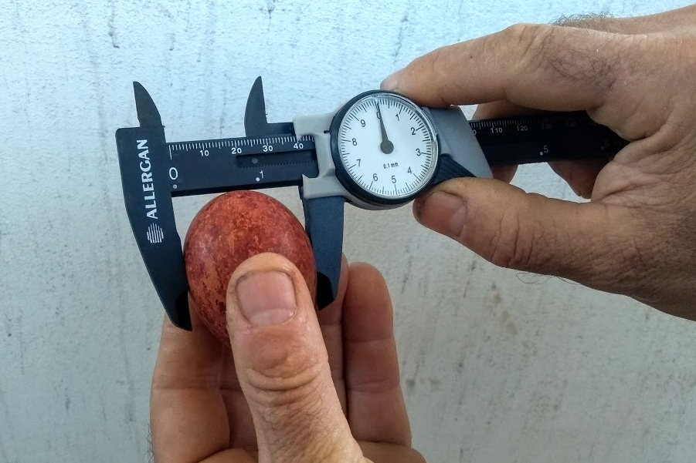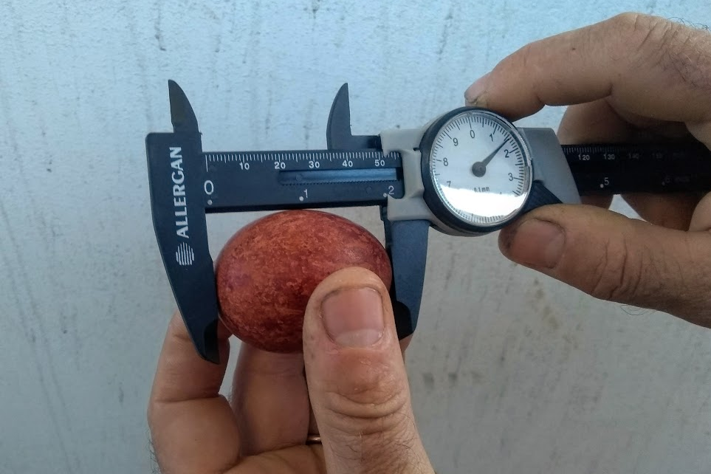
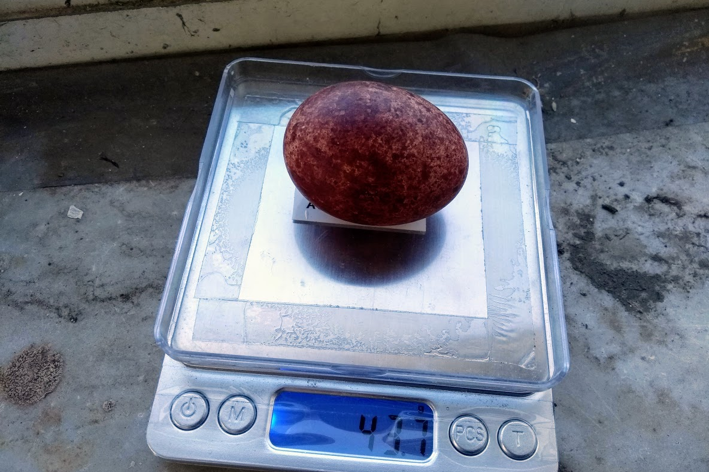

4.2 Pre-printed data sheet

5. References
Anderson, D. L., Franke, A., & McClure, C. J. (Eds.). (2017). Applied raptor ecology: Essentials from gyrfalcon research. Peregrine Fund.
Bijlsma, R. G. (1997). Handleiding veldonderzoek roofvogels. De takkeling, 5(1), 5-6.
Burnham, W. (1983). Artificial incubation of falcon eggs. The Journal of Wildlife Management, 158-168.
Cade, T. J., Enderson, J., & Linthicum, J. (Eds.). (1996). Guide to management of Peregrine Falcons at the eyrie. Peregrine Fund.
Clum, N.; Harrity, P. and Heck, W. (1996): Aging young Peregrines.
Cramp, S. and Simmons, K.E.L. (1980) The Birds of the Western Palearctic. Vol. II, Oxford University Press, Oxford.
Demongin, L. (2016). Identification guide to birds in the hand. Cambridge: Cambridge University Press.
Drewitt, E. (2014). Urban peregrines. Pelagic Publishing Ltd.
Espín, S., García-Fernández, A. J., Herzke, D., Shore, R. F., van Hattum, B., Martínez-López, E., ... & Jaspers, V. L. B. (2014). Sampling and contaminant monitoring protocol for raptors. Research Networking Programme-EURAPMON, Research and monitoring for and with raptors in Europe. Available on www. eurapmon. net.
Franke, A., K. Steenhoff, and C. L. McIntyre. 2017. Terminology. Pages 33-42 in D. l. Anderson, C. M. McClure, and A. Franke, editors. Applied raptor ecology: essentials from Gyrfalcon research. The Peregrine Fund, Boise, Idaho, USA. (downloads available here: http://science.peregrinefund.org/applied-raptor-ecology-chapters)
Hardey, J., Crick, H., Wernham, C., Riley, H., & Thompson, D. (2009). Raptors: a field guide to survey and monitoring. Edinburgh: The Stationery Office.
Hoyt, D. F. (1979). Practical methods of estimating volume and fresh weight of bird eggs. The Auk, 96(1), 73-77.
Hurley, V. G., Hogan, F., White, J. G., & Cooke, R. (2007). A morphological model for sexing nestling peregrine falcons (Falco peregrinus macropus) verified through genetic analysis. Wildlife Research, 34(1), 54-58.
Lowe, K. W. (1989). ‘The Australian Bird Bander’s Manual.’ (Australian National Parks and Wildlif Service, Commonwealth of Australia: Canberra.)
Mebs, T. (1960). Untersuchungen über den Rhythmus der Schwingen-und Schwanzmauser bei großen Falken. Journal für Ornithologie, 101(1-2), 175-194.
Miller, A. H. (1941). The significance of molt centers among the secondary remiges in the Falconiformes. The Condor, 43(2), 113-115.
Movalli, P., Valvo, M. L., Pereira, M. G., & Osborn, D. (2008). Organochlorine pesticides and polychlorinated biphenyl congeners in lanner Falco biarmicus feldeggii Schlegel chicks and lanner prey in Sicily, Italy. AMBIO: A Journal of the Human Environment, 37(6), 445-452.
Odsjö, T., Roos, A., & Johnels, A. G. (2004). The Tail Feathers of Osprey Nestlings (Pandion haliaetus L.) as Indicators of Change in Mercury Load in the Environment of Southern Sweden (1969–1998): Case Study with a Note on the Simultaneous Intake of Selenium. AMBIO: A Journal of the Human Environment, 33(3), 133-138.
Peakall, DB. (2011) Dde-induced eggshell thinning: an environmental detective story. Environmental Reviews 1 (1): 13-20
Poole, K. G. (1989). Determining age and sex of nestling Gyrfalcons. Journal of Raptor Research, 23, 45-47.
Rahn, H., & Ar, A. (1974). The avian egg: incubation time and water loss. The Condor, 76(2), 147-152.
Ratcliffe, D. (1967). Decrease in eggshell weight in in certain birds of prey. Nature, 215: 208-210.
Ratcliffe, D 1993 The peregrine falcon. A&C Black.
White, C. M., N. J. Clum, T. J. Cade, and W. G. Hunt (2002). Peregrine Falcon (Falco peregrinus), version 2.0. In The Birds of North America (A. F. Poole and F. B. Gill, Editors). Cornell Lab of Ornithology, Ithaca, NY, USA. https://doi.org/10.2173/bna.660
Zuberogoitia, I., Zabala, J., & Martínez, J. E. (2018). Moult in birds of prey: a review of current knowledge and future challenges for research. Ardeola, 65(2), 183-208.

6. Links and books for further reading

- Clark, W. S. (2007). Raptor identification, ageing, and sexing. Raptor Research and Management Techniques, Bird DM & Bildstein KL (eds) pp, 47-55.
- Ristow, D. (1999). International Species Action Plan Eleonora’s Falcon Falco eleonorae. Birdlife International, Council of Europe, Cambridge.
- Weaver, J. D., & Cade, T. J. (1991). Falcon propagation. The Peregrine Fund, Boise, ID USA.

Measuring
- Book:
ECK, Siegfried, Till TÖPFER, Jürgen FIEBIG, Iris HEYNEN, Wolfgang FIEDLER, Bernd NICOLAI, Renate VAN DEN ELZEN, Raffael WINKLER, Friederike WOOG, TÖPFER, Till, ed., Iris HEYNEN, ed., 2011. Measuring Birds. Minden:Christ Media Natur. ISBN 978-3-923757-05-3
- Labocha, M. K., & Hayes, J. P. (2012). Morphometric indices of body condition in birds: a review. Journal of Ornithology, 153(1), 1-22.

Aging
- The Canadian Peregrine Foundation: Peregrine Falcon Development - Age Guide

http://www.peregrine-foundation.ca/info/ageguide.html
- Clum, N.; Harrity, P. and Heck, W. (1996): Aging yong Peregrines. In Cade, T.J.; Enderson, J.H. & Linthicum, J:Guide to management of Peregrine Falcons at the eyrie. The Peregrine Fund & Santa Cruz Predatory Bird Research Group.

- Anderson D. L., K. K. Burnham, Ó. K. Nielsen, and B. W. Robinson. 2017. A photographic and morphometric guide to aging Gyrfalcon nestlings. Pages 265–282 in D.L. Anderson, C.J.W. McClure, and A. Franke, editors. Applied raptor ecology: essentials from Gyrfalcon research. The Peregrine Fund, Boise, Idaho, USA.

https://doi.org/10.4080/are.2017/app1. http://assets.peregrinefund.org/docs/project-data/book-applied-raptor-ecology/a1-applied-raptor-ecology.pdf

Legal considerations
- http://raptormonitoring.org/legal-considerations-when-working-with-raptors

Ringing Guidelines
- https://www.bto.org/volunteer-surveys/ringing/taking-part/resources-ringers/resources-data-collection

Feather Identification
- https://www.fws.gov/lab/featheratlas
- http://www.vogelfedern.de

Intentional poisoning
- https://www.youtube.com/watch?v=VGJKvpKBZA4

