Vulture Guidance for Biomonitoring

Guidance for Biomonitoring Using Vultures as Indicators for Contamination in The Environment

Preface
The European Raptor Biomonitoring Facility (ERBFacility) COST Action () is an open network of researchers and practitioners working towards coordinated Europe-wide monitoring of contaminants in raptors with a view to supporting the implementation of EU chemicals regulations and thereby reducing chemical risks to raptors themselves, to the wider environment and to human health.

Please visit the ERBFacility webpage for additional information: https://erbfacility.eu/

Overall project management
ERBFacility is coordinated through a Management Committee (MC). The Chair, Vice-Chair, Working Group Leaders (WGLs) and Grant Holder were elected at the first MC meeting in October 2017. A Core Group (CG) is responsible for steering and monitoring the Action in accordance with work plans and budgets approved by the MC. The CG comprises the MC Chair, Vice-Chair, WGLs, Grant Holder, STSM Coordinator and Communications Manager.

Core Group
Guy Duke (Environmental Change Institute, University of Oxford, UK), ERBFacility Chair
Al Vrezec (National Institute of Biology, Slovenia), ERBFacility Vice-Chair
Lee Walker (Centre for Ecology and Hydrology, UK) Leader Working Group 1 * (note)
Lee Walker (Centre for Ecology and Hydrology, UK) Leader Working Group 1
Antonio J. García-Fernández (University of Murcia, Spain), Leader Working Group 2
Paola Movalli (Naturalis Biodiversity Center, Netherlands), Leader Working Group 3
Chris Wernham (British Trust for Ornithology, UK), Leader Working Group 4
Oliver Krone (Leibniz Institute for Zoo and Wildlife Research, Germany), STSM Coordinator
Compilers
(name and email)
Yael, Stavros, Arianna, Silvia, Pablo, Pilar and me

Contributors
(name, organization and email)
All that have provided contribution
Antonio…

Scope
This document is gathering information based on expertise related to the four European vulture species: Griffon Vulture (Gyps fulvus), Bearded Vulture (Gypaetus barbatus), Cinereous Vulture (Aegypius monachus) and Egyptian Vulture (Neophron percnopterus), although we believe that can apply to most of the Old World vulture species.

Date
Drafting period 2020-21, published November 2021

Recommended citation
(compilers (EDs) Year. Title. Project name. publication number.)

CONTENTS

Introduction

Vultures are a characteristic, distinctive and spectacular component of the biodiversity of the environments they inhabit. They also provide critically important ecosystem services by cleaning up carcasses and other organic waste in the environment: they are nature’s garbage collectors and this translates into significant economic benefits.

Thanks to intensive conservation efforts, populations of some vultures have recovered in some parts of Europe, although poisoning (intentional and not intentional) remains to be a main threat to the species worldwide. Other threats to vultures, operating variably in all regions, include such problems as habitat loss or degradation, food availability, collisions and electrocution by electricity power lines.

We chose the four vulture species of Europe as sentinels for environmental contamination monitoring. Vultures have a high potential for biomonitoring environmental quality on vast geographic scales due to their wide-ranging foraging behaviour and extensive distribution area, which extends almost all-over south Europe. Their diet is diverse and contains carcasses of medium and large size domestic and wildlife animals. As highly specialized carrion feeders, vultures are more susceptible to pharmaceuticals given to livestock like cattle and sheep, which are their main food sources in farming areas. They are also exposed to other anthropogenic contaminants such as organophosphorus and carbamate pesticides from agricultural practices, and lead from hunting ammunition. These characteristics make vultures suitable for reflecting the health of the environment and give warning to problems caused by exposure to environmental contaminants that need our attention and awareness.

A well-known example is the critical decline of Gyps vulture populations in Asia due to their susceptibility to diclofenac, a non-steroidal anti-inflammatory drug legally administered to livestock (Oaks et al. 2004; Margalida et al. 2014). Although the diclofenac crisis received widespread attention due to its devastating consequences, other substances may cause acute mortality or sublethal effects that can go unnoticed. The deliberate poisoning of animals by humans poses an additional threat to vultures, since poisoned prey may lead in secondary poisoning for scavengers (Guitart et al. 2010). In addition, massive poisoning events may occur because vultures often feed communally at a single carcass (Plaza et al. 2019). Furthermore, vultures can be exposed to metals such as lead (Pb) from different sources (e.g., ingestion of ammunition from hunting remains in the field, mining activities, etc.) (Mateo et al. 1997; García-Fernández et al. 2005; Espín et al. 2014; Monclús et al. 2020). Depending on the concentrations reached in the organs, it may alter their physiology, behaviour and nervous, renal, reproductive and immune systems, or cause lethality (Monclús et al. 2020). Recent research has shown the value of coordinated biomonitoring at a widespread scale over a long time period: Descalzo et al. 2021 assessed lead exposure in 16 raptor species in Spain and found 74% of Griffon Vultures had abnormal blood lead levels, with lethal and sublethal effects. Exposure to other contaminants with potential consequences may also occur (Espín et al. 2014; Monclús et al. 2018). As a result, an increasing number of biomonitoring studies track spatial-temporal trends in chemical exposure and related adverse effects using raptors, including vultures, as valuable indicators of environmental pollution (Gómez-Ramírez et al. 2014; Espín et al. 2016).
Griffon Vultures (Gyps fulvus) have a high potential for biomonitoring environmental quality on vast geographic scales due to their wide-ranging foraging behaviour and extensive distribution area, which extends almost all over Europe (Cramps and Simons 1980, Mundy et al. 1992). GPS data shows these vast long-distance foraging ranges (Sušic 2000, Monsarrat et al. 2013, Zuberogoitia et al. 2013, Alarcón and Lambertucci 2018, Duriez et al. 2019). Even with these characteristics, Griffon Vultures are essentially non-migrants and reflect their exposure to contaminants all year round. Never the less, these long-distance movements may pose some difficulties to evaluate their actual feeding grounds and, consequently, the exact exposure sites. Therefore, a good knowledge of their ecology and movements may help to better interpret the risks associated with the exposure to toxic substances.

Vulture species

There are 16 vulture species classified as Old World vultures distributed across Africa, Asia and Europe. This work is based on the experience with the four European vulture species: Griffon Vulture (Gyps fulvus), Bearded Vulture (Gypaetus barbatus), Cinereous Vulture (Aegypius monachus) and Egyptian Vulture (Neophron percnopterus). These species are large birds (2-8kg), adapted for energy efficient soaring flight exploiting updraughts and thermals. They feed on organic tissues from carcasses of large mammals and other carrion located from the air, by seeing either the carcass itself or the responses of other vultures to it. They eat meat, offal, intestines and bones, typically of domestic cattle or wild ungulates, and can take sufficient food into the crop at one meal to last several days. Nests are typically on cliffs or in trees; some species are colonial breeders. However, the different species are presenting particular characteristics described below, that should be taken into an account when used as indicators for contamination in the environment.

Griffon vulture (Gyps fulvus)

Data source and more info: http://datazone.birdlife.org/species/factsheet/griffon-vulture-gyps-fulvus

Distribution and movement: The Griffon Vulture have a large distribution range, extending over Europe, the Middle East and formerly North Africa (Mundy et al. 1992) to Turkey, the Crimean Peninsula and the Caucasus, all the way to Pakistan and north India (Katzner et al, 2004). Although it is not a migratory species, can be considered as partial migrant. Breeding adults are largely sedentary, some individuals, mainly juveniles and sub-adults which do not breed, are migratory or nomadic (Donázar 1993, Susic 2000). In Europe, those young individuals migrate during autumn to Africa, passing mainly through north Africa, to spend the non-breeding season there (del Hoyo et al. 1994). In south-western Europe, some French birds join the autumn migration of Spanish birds to northern Spain and western Africa (Terrasse 2006); these birds return to France in late winter and early spring, often accompanied by Spanish birds.
Ecology and habitat: The Griffon Vulture congregate to roost on large cliffs in remote areas. Generally, these cliffs occur from sea level up to an elevation of 1,500 m and occasionally as high as 2,500 m (Slotta-Bachmayr et al. 2006). The roosting cliffs support the formation of thermals (Mebs and Schmidt 2006) as the large vultures prefer to save energy by gliding and soaring, over active flight. They soar communally over the surrounding open countryside in search of food, while avoiding woodlands and preferring open landscapes. Being almost exclusively a carrion feeder of medium-to-large sized domestic and wild ungulates, the mutual soaring enables individuals to better spot carcasses in the vast foraging range. The cliffs also provide a suitable and protected nesting site for the colony that can contain up to 100 pairs of Griffon vultures. The nest is usually built on a rocky outcrop, with sheltered ledges or small caves that are preferred by the nesting parents (del Hoyo et al. 1994).

Bearded vulture (Gypaetus barbatus)

Data source and more info: http://datazone.birdlife.org/species/factsheet/bearded-vulture-gypaetus-barbatus

Distribution: In Europe, the species distribution is patchy, after disappearing from almost all the mountains ranges of the continent during the last two centuries mainly due to human induced causes. Its population in the Balkans was the last to become extinct, as late as in the beginning of this century (Andevski 2013), and remained only in the Pyrenees, Corsica and Crete. Since the mid-1980s the Bearded vulture has been successfully reintroduced to several European mountain ranges, initially in the Alps (Austria, France, Italy and Switzerland) and more recently in Spain (Andalusia, and Picos de Europa) and France (Grands Causses) (Zink and Waldvogel 2015). In Asia, the main and substantial populations occur along the Himalayas, extending from central Asia to the west (including north India, Pakistan, Afghanistan) up to central China, Mongolia and the Altai region in the east. Middle Eastern populations extend from southwest Iran, Turkey, and Yemen as well as southwest Saudi Arabia. In Africa the species occur across Ethiopia, Kenya and Tanzania, Lesotho and South Africa, and the Atlas Mountains in Morocco. The Bearded vulture is regarded as a sedentary species showing a strong philopatric behaviour foraging within close proximity of active nests (Krüger 2015) but young birds wander widely over vast areas of around 10,000 km2 before becoming territorial (Donázar 1993, Ferguson-Lees and Christie 2001, Margalida et al. 2016).
Ecology: In the western Palearctic the species occupies remote mountainous areas above 1,000m, with precipitous terrain and good populations of medium-sized wild or domestic ungulates consuming the carcasses left by predators or other scavengers (Ferguson-Lees and Christie 2001). The species diet constitutes primarily on bones (70%), soft tissues (25%) and skin (5%) (Hiraldo et al. 1979). The species is monogamous, but trios (two males and one female) are also often documented (Razin 2015). Nests are quite large (averaging 1 m diameter), composed of branches and wool and situated on remote overhanging cliff ledges or in caves. The breeding season extends from December to June-September in Eurasia and northern Africa; October-May in Ethiopia; May-January in southern Africa (Ferguson-Lees and Christie 2001). Eggs are incubated for 54 days and nestlings fledge after almost four months (Margalida 2002). In the case where two eggs are laid, obligatory “cainism” occurs in which the older sibling kills the younger (Thaler and Pechlaner 1980).

Cinereous vulture (Aegypius monachus)

Data source and more info: http://datazone.birdlife.org/species/factsheet/cinereous-vulture-aegypius-monachus

Distribution and movements: The Cinereous Vulture has a large distribution range across Europe, Asia and North Africa. It breeds in Portugal (recent recolonization), Spain (including the only island population in Mallorca), France (reintroduced population, now self- sustaining), Greece, Turkey, Armenia, Azerbaijan, Georgia, Ukraine, Russia, Uzbekistan, Kazakhstan, Tajikistan, Turkmenistan, Kyrgyzstan, Iran, Afghanistan, northern Pakistan (Khan, Parveen and Yasmeen in lit. 2005), Mongolia and mainland China (Heredia 1996, Heredia et al. 1997, Skartsi et al. 2008, Skartsi et al. 2010, V. Galushin in lit. 1999). The wintering range includes additional states to the south of the breeding range, in Saudi Arabia, Iran, northern India, Nepal, Bhutan, Bangladesh, DPR Korea and Republic of Korea. It appears to be very rare and of irregular occurrence in Africa (e.g. Egypt: Goodman and Meininger 1989), with no reliable records in Sudan (Nikolaus 1987). The species is a partial migrant (Bildstein 2006); while it is sedentary in some areas, many individuals winter south of the breeding range, and there is also a good deal of nomadism. Gavashelishvili and McGrady (2006) recorded long range movements by a bird that fledged in Georgia, travelled south to Saudi Arabia, and then headed north into Russia. Many adults and juveniles in Mongolia apparently migrate in autumn to wintering areas in the Republic of Korea (South Korea) (Batbayar 2004, Batbayar et al. 2006), while birds from central Asia migrate to the Indian subcontinent, southern China, Russian Far East, and the Republic of Korea (Batbayar 2006). In Europe, the adults are mostly sedentary, while the juvenile birds disperse over larger areas. In Spain, the movements of the juveniles are mainly limited to the western and central part of the Iberian Peninsula and in the surroundings of the breeding colonies (Moreno-Opo and Guil 2007). Movements of individuals to and from Spain, France, Portugal and Italy have been recorded in recent years. Also, birds from the Dadia- Lefkimi-Soufli Forest National Park colony in North-eastern Greece regularly visit the nearby vulture feeding sites in southern Bulgaria, and disperse in the wider range of Rhodope Mountain (Vasilakis e al. 2008, Vasilakis et al 2016, Vasilakis et al. 2017) with some moving into Turkey (Skartsi pers. com 2016). Reports of Cinereous Vultures as regular winter visitors to Africa (Egypt and Sudan) appear to be unfounded, at least recently, although very small numbers have been recorded (less than annually) in Egypt. Few birds are recorded crossing the Gibraltar Strait yearly. At least two birds from Spain and France respectively have been recovered in Senegal and Mali after being marked at their respective breeding colonies (Cantos and Gómez-Manzaneque 1996).
Ecology and habitat: The species prefer arid hilly and montane habitat, including wooded areas and semi-desert, areas above treeline, and agricultural habitats with patches of forest. Birds spend much time soaring overhead in search of food. They perch more often on trees than on cliff faces or on the ground. Although not numerous, in places of abundant food they may congregate in large flocks (Flint 1984). The species inhabits forested areas in hills and mountains at 300-1,400m in Spain, but occurs at higher altitudes in Asia, where it also occupies scrub and arid and semi-arid alpine steppe and grasslands up to 4,500 m (Thiollay 1994). It forages over many kinds of open terrain, bare mountains, steppe and open grasslands. Nests are built in trees or on rocks (the latter extremely rarely in Europe but more frequently in parts of Asia), often aggregated in very loose colonies or nuclei. Its diet consists mainly of carrion from medium-sized or large mammal carcasses, although snakes and insects have been recorded as food items. Live prey is rarely taken. In Mongolia, at least, the species is reliant on livestock numbers for successful nesting (Batbayar et al. 2006).

Egyptian vulture (Neophron percnopterus)

Data source and more info: http://datazone.birdlife.org/species/factsheet/egyptian-vulture-neophron-percnopterus

Distribution and movements: the Egyptian Vulture is a Palearctic, Afrotropical and western Indohimalayan species: a breeding (summer) migrant across the northern part of the range, but with resident populations and non-breeding visitors further south. The northern breeding range includes southern Europe and North Africa eastwards through the Balkans, Turkey, Iran, Kazakhstan, Turkmenistan, Uzbekistan, Tajikistan, Kyrgyzstan, Georgia, Azerbaijan and Armenia. There are sedentary populations in Spain: on Balearic Islands (on Menorca mainly), as well as an endemic subspecies of the Canary Islands (Neophron percnopterus majorensis), consisting of less than 40 pairs in each case (Kretzmann et al. 2003); recently, a wintering population of 120 individuals was recorded in Extremadura (Sánchez at al. 2015). A very small resident population is also present on Cape Verde Islands. In 2019, a breeding pair successfully breed in Sardinia Island (Italy), previously known in the area only as very rare vagrant (Grussu 2001). The smaller Asian subspecies (ginginianus) is largely sedentary, remaining within the Indian sub-continent (Pakistan, India, Nepal), although other populations (of the nominate race) are also sedentary in Arabia (Oman, UAE, Saudi Arabia and Yemen) as well as much of the central and East African range. The African range is concentrated along a broad band of the Sahel from Sudan (Nikolaus 1987) and Ethiopia (holding the largest African breeding population: Mundy et al. 1992), Somalia, Eritrea and Djibouti west to Senegal (Rondeau & Thiollay 2004, Petersen et al. 2007, Wacher et al. 2013) and south to Kenya and northern Tanzania. It also occurs in North Africa (Morocco, Tunisia, Algeria, Libya and Egypt: Levy 1996). A few resident pairs may occur in Angola, but it is currently considered regionally extinct as a breeding species in South Africa (Taylor et al. 2015) and Namibia (Simmons et al. 2015). Northern breeders conduct long distance intercontinental migrations, flying over land and often utilise the narrowest part of the Strait of Gibraltar or the Bosphorus and Dardanelles on their way to sub-Saharan Africa (García-Ripollés et al. 2010, López-López et al. 2014, Oppel et al. 2015). Other known migration bottlenecks are the Gulf of Iskenderun in Turkey (Oppel et al. 2014), Suez in Egypt (Bougain & Oppel 2016), and Bab el Mandeb between Yemen and Djibouti (McGrady et al. 2013). Egyptian Vultures are rare and irregular visitors to southern Africa, where they used to breed; a few may still do so in northern Namibia
Migratory adult birds spend about 6-7 months on the breeding grounds (March-September) and the rest of the year along the flyway and in the wintering grounds. After the first migration (August-October), the juvenile Egyptian vultures remain in the wintering regions for at least 1.5 years (in some cases up to three years) and do not attempt spring migration in the year after their first arrival in Africa (Oppel et al. 2015).
Habitat: In most parts of its breeding range, this species inhabits arid woodlands and semi-arid bush country often near villages and along roads. It usually occurs singly or in pairs, less commonly in small groups, and rarely in large groups of more than 100. The wintering habitat includes mainly sub-deserts and savanna in the Sahel zone (Oppel et al. 2015; Meyburg et al. 2004) where birds often roost on pylons (Arkumarev et al. 2014).The Egyptian vulture typically nests on ledges or in caves on cliffs (Sarà and Di Vittorio 2003), crags and rocky outcrops, but occasionally also in large trees, buildings (mainly in India), electricity pylons (Naoroji 2006) and exceptionally on the ground (Gangoso and Palacios 2005). It forages in lowland and montane regions over openwhile scavenging at human settlements, being an opportunistic scavenger with a broad diet (e.g: tortoises, organic waste, insects, faeces Margalida et al. 2012, Dobrev et al. 2015, 2016). Although usually solitary, it will congregate at feeding sites (eg: rubbish tips, supplementary feeding stations Ceballos & Donázar 1990). The species exhibits high site fidelity, particularly in males (Elorriaga et al. 2009, García-Ripollés et al. 2010, López-López et al. 2014).

Threats affecting vultures

As for most, if not all, vulture species, poisoning is the most severe threat. This is the reason for the vulture species extinction or decline in a significant part of their distribution range, and one of the main constraints for their recovery. In general, poison is not used to intentionally kill vultures – these birds are normally secondary or tertiary victims of poison used against predators (foxes, wolves, feral dogs, etc.) regarded to be in conflict with human activities such as livestock husbandry and hunting. Poisoning can also be unintentionally caused by agrochemicals (pesticides), veterinary pharmaceuticals (used in livestock), and lead ammunition from hunting activities. Poisoning is not the only threat to vultures, unfortunately there are other threats causing significant mortality to vultures or reducing the breeding productivity, therefore enabling their recovery and causing extinction. Detailed analyses of the threats affecting each vulture species were made during the Vulture MsAP process (Vulture MsAP 2018), where apart of poisoning, electrocution and collision with electricity infrastructure, such as the decline of food availability were highlighted as a critical threats to the European vulture species, but certainly relevant to all vulture species globally. We provide the graphic categorization and prioritization of the threats to vultures at global level (Vulture MsAP, 2018).

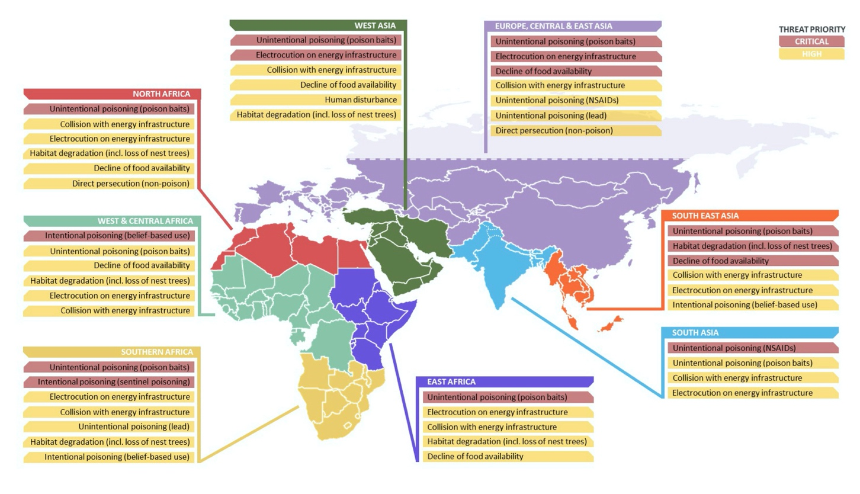

Poisoning
Poisoning is the most severe threat for all vulture species at a global scale. This has been the major cause of vulture decline and extinction across significant parts of their distribution range and still remains one of the main constraints for their population recovery. Overall vultures suffer from primary poisoning by consuming poisoned baits used against pest species namely animals that conflict with human activities by causing damages to crop, livestock or game or secondary poisoning after feeding on poisoned carcasses (Virani et al. 2011, Ogada et al. 2012 and Botha et al. 2012). Poisoning is normally caused by agrochemicals (synthetic pesticides such as organochlorines, organophosphates, carbamates and pyrethroids) (Ogada 2014). Poisoning by veterinary pharmaceuticals has caused catastrophic declines to vultures. The effects of poisoning with NSAIDs, and particularly diclofenac, has been quantified using a variety of approaches and shown to be the main impact on Gyps vulture populations in Asia causing the sharpest population declines over the shortest timeframe of any known group of birds in history. Diclofenac was used extensively for domestic livestock and any animals that then died within two days of treatment had highly toxic levels in the tissues that would cause kidney failure and death of any vulture feeding on the carcass (Oaks et al. 2004, Shultz et al. 2004, Green et al. 2004, Swan et al. 2006). There is evidence that other NSAIDs in legal veterinary use are also toxic to vultures, as well as possibly to other scavenging birds (Swarup et al. 2007). Other NSAIDs toxic to vultures include Nimesulide, Carprofen, Flunixin, and Ketoprofen were also identified as lethal to Gyps vulture species (Naidoo et al. 2010, Zorrilla et al. 2014, Cuthbert et al. 2016, Cuthbert et al. 2007), and residues of these drug found in ungulate carcasses in sufficient concentrations may cause mortality in vultures (Taggart et al. 2007).
Lead ammunition from game-hunting activities could have both lethal and sub-lethal effects to all scavengers often causes sub-lethal poisoning with a number of secondary effects such as reduced mobility or increased risk of collision and reduced breeding success (Naidoo et al. (2017). Lead poisoning may be the most significant threat to Bearded Vultures in Europe (Margalida et al. 2008) and there are also evidences of negative effects of accidental lead intoxication to Cinereous and Egyptian Vultures (Pikula et al. 2013, Bounas et al. 2016). Substantial work has been carried out on the impact of lead poisoning on the recovery of the California Condor (Gymnogyps californianus) and this threat is considered the most significant in terms of the species’ successful reintroduction in the wild (Finkelstein et al. 2012).
Pollution of the environment by a range of chemicals can also affect vultures’ food or water source and have an unintended impact on their populations due their longevity high trophic level in the food chain. Bioaccumulation may have sub-lethal but significant negative effects on reproductive success, immune response and behaviour.

Electrocution and collision
Bird mortality by electrocution on power poles is a global problem that has become more prevalent in recent years as energy demand increases, resulting in infrastructure growth often in previously undeveloped areas. Electrocution associated with powerlines occurs when a bird comes into contact with two wires, one of which is live, or when it perches on a conductive pylon (for example, a metal structure) and comes into simultaneous contact with a live wire. Large species such as vultures, eagles and storks are particularly vulnerable. Electrocution risk can be very significant in old, badly designed and insulated poles and poorly sited power lines. Effective planning, design and mitigating measures can dramatically reduce the impact of energy infrastructure on avian populations (BirdLife International 2017). Electrocution by power lines is among the main causes of vulture decline in Europe, significantly affecting the Egyptian Vulture population in the Canary Islands (Donazár et al. 2002) and the Griffon Vulture population in Israel (Leshem et al. 1985). In a recent study on the movement of 60 adult Griffon Vultures equipped with 90 gr GPS/GPRS-GSM devices from e-obs digital telemetry the main mortality cause was electrocution in power lines and collisions in wind farms (Donázar pers. comm.).
Also, the collisions with wind turbines are by far the most important mortality sources for the Griffon Vultures in Spain (Carrete et al. 2012). For example, more than 5600 griffon vultures have died at wind farms in five Spanish regions between 1996 and 2016 (Andalucía, País Vasco, Aragón, Navarra, Valencia) compared to 1526 poisoned in the whole of Spain between 1992 and 2013 (Cano et al. 2016). Collisions with wind turbines are also significant threats for the Egyptian Vulture, with local populations in Spain (the main stronghold of the species in Europe) declining through a combination of mortality derived from collisions and poisoning (Carrete et al., 2009; Sanz-Aguilar et al. 2015).

Decline of food availability
As obligate scavengers feeding on carcasses of various sizes, vultures are susceptible to declines in the availability of carcasses, especially of ungulates. Four main factors could reduce food (carcass) availability for vultures. First, a reduction in the numbers of dead livestock could result from carcasses sanitary treatment (being buried or burned), or dumping sites for carcasses being closed entirely. These measures could be prompted by strict sanitary regulations or risks to public health. Second, competition for food with feral dogs and other scavengers: an example of this is the increase in feral dog populations in India (Cunningham et al. 2001, Markandya et al. 2008) following the decline in vultures due to poisoning by NSAIDs. Third, reduced wild ungulate populations diminish food availability for vultures where these are more important than livestock. And, fourth is the impact of improved animal husbandry (intensification) which results in fewer carcasses being available for vultures to feed on (Mundy et al. 1992). In Europe the decline in food availability for vultures is mostly related to decrease of wild ungulates and livestock.

Contaminants in vultures

Generally, diet is the main source for chemical exposure in vultures, as well as all vertebrates. Livestock carcasses, either disposed at supplementary feeding stations (SFS) or abandoned around farms or grazing areas are a common diet which usually expose scavengers to pharmaceuticals, mainly antibiotics, non-steroidal anti-inflammatory drugs (NSAIDs) and topical antiparasitics (Gómez-Ramírez et al., 2020, 2018; Mateo et al., 2015). The class of compounds and magnitude of exposure may be influenced by geographical location, which in turn is related to the species and age of livestock bred in the area, pathogens and illnesses commonly found, availability/registration of products, habits of veterinary medication and the type of farming practices (extensive vs. intensive) (Blanco et al., 2017). Carcasses from ailing and treated animals can be disposed in SFS and ingested by scavengers almost immediately after their death, so they can be exposed to relatively high concentrations (Blanco et al., 2016). In the case of anticoagulant rodenticides (ARs), scavengers can be exposed by different routes: ingesting carrion baits, scavenging intoxicated animals (rodents or poisoned animals) or, due to the bioaccumulation potential persistence in the liver of exposed animals, by scavenging animals that may have died due to other causes but were exposed to ARs (Berny et al., 2015; Kelly et al., 2014).

Common contaminants in vultures

Pesticides, mainly carbamates, in poisoned baits
Conflicts between human and wildlife is the main origin of the use of poisoned baits to kill wildlife, which compete with farmers on their crops and prey on their livestock. These baits are usually prepared with pesticides based in different chemical groups such as carbamates, organophosphorous, organochlorine, strychnine, etc. In general, according to the main schemes on prevalence of poisoning in wildlife, anticholinesterase pesticides, mainly carbamates, are the chemicals more frequently detected in deliberated poisoning cases in the world (references UK, France, Spain, etc schemes). Sometimes vultures are the primary target of these poisoned baits, but in the majority of cases vultures are victims of secondary lethal poisoning due to the ingestion of carcasses of poisoned animals. The compounds more frequently detected in poisoned wildlife (including vultures) are two N-methylcarbamate insecticides, aldicarb and carbofuran, whose mean lethal doses in birds have been set in 0.8-10 mg/kg and 0.4-6.3 m/kg, respectively (García-Fernández et al., 2006; Gupta, 1994). The use of these chemicals is banned in Europe since 2003 and 2005 for aldicarb and carbofuran, respectively, but there is illegal traffic all over the world. Acute clinical signs of these chemicals are associated to the inhibition of acetylcholinesterase by carbamylation inducing preponderantly hyper-cholinergic symptoms and others involving effects on the central and peripheral nervous systems, musculoskeletal, ocular, cardiovascular, reproductive, immunologic systems (Gupta, 2014). Due to their extreme toxicity and rapid interaction with receptors, low doses of aldicarb or carbofuran can produce immediately the death of the animals.

Lead
Lead is generally recognized as one of the main chemical threats, if not the greatest, on vulture conservation in all parts of the world (Plaza and Lambertucci, 2019). Although there are many different sources of environmental lead (mines and smelters, urban and industrial airborne dust, lead-based paints, etc), ammunition is probably the main source of lead poisoning in waterfowl, but also in vultures and other scavenging birds that ingest the flesh of game species (García-Fernández, 2014; Arrondo et al., 2020). The first data published in Europe (Southern Spain) on blood lead concentration (BLC) in large avian scavengers was 37.9 ± 12.1 μg/dL and 43.1 ± 32.0 μg/dL in Griffon vultures sampled in 1993 and 2003, respectively (García-Fernández et al., 1995, 2005). A decade later, in 2014, the 80% of the Griffon vultures sampled in Southern Spain had BLC higher than 50 μg/dL (Arrondo et al., 2020). It has been suggested that probably Griffon vultures tolerate lead exposure more than other large body-sized facultative scavenger species (García-Fernández et al., 2005, Espín et al., 2014, Arrondo et al., 2020). In spite of this, we cannot discard negative effects by chronic exposure in bone mineralization, behavioral alterations and physiological effects such as inhibition of d-ALAD activity (Espín et al., 2015, Arrondo et al., 2020).

Barbiturates
Barbiturates are euthanasia agents used in veterinary medicine and as the rest of pharmaceuticals they are being considered as emerging contaminants for wildlife (Herrero-Villar et al. 2021). Intoxication with barbiturates in wildlife is generally due to accidental secondary poisonings, although in some cases they have also been used intentionally to kill scavengers, both mammals and birds (María-Mojica et al., 2018). Generally, pentobarbital is the most frequently detected barbiturate in scavengers, mainly due to the consumption of euthanized animals used as carrion in SFS (María-Mojica et al., 2018). Immediately after injection, barbiturates are rapidly distributed into the body of euthanized animals, reaching higher concentrations in the highly vascularized organs such as liver, kidneys, lungs, spleen, heart, etc with much lower concentrations in muscle (Aldeguer et al., 2009). Therefore, vultures ingesting viscera of the carcasses will be it greater risk of lethal poisoning than those ingesting muscle tissue.

Veterinary pharmaceuticals, mainly NSAIDs and antibiotics
Although other classes of medicines can be used to treat livestock, these are the most frequently studied and detected in vultures. The sensibility of Gyps vultures to the NSAID diclofenac was discovered due to the high rates of mortality that it caused after the ingestion of treated livestock, leading to a decrease in Asian populations (Oaks et al. 2004). This paradigm in avian ecotoxicology has led to further investigations finding that this sensitivity varies among vulture species and NSAIDs. In this sense, flunixin and ketoprofen have also been identified as cause of intoxication in vultures (María-Mojica et al., 2018; Naidoo et al., 2010; Zorrilla et al., 2015). The threat of exposure to antibiotics is still under study, although there is a clear concern related to their role as a cause of microbial resistance and predisposition to fungal infections (Gómez-Ramírez et al., 2018).

Topical antiparasitics
These have been very rarely investigated as a cause of intoxication (Henny et al., 1987; Mineau et al., 1999), but organophosphate compounds (diazinon, pirimiphos-methyl, chlorpyrifos, fenthion) and permethrins have been identified as a risk for vultures fed in SFS in progress (Mateo et al., 2015).
Anticoagulant rodenticides
Adverse effects of ARs, whose severity depends on the dose and the intra or interspecies differences, are based on the multiple organ response, with haemorrhages in skin, muscle, kidney, central nervous, respiratory, gastrointestinal and reproductive system (Rattner et al., 2014). Thus, animals exposed to ARs can die either due to lethal bleeding or to the consequences of sublethal haemorrhages (trauma, infectious and parasite diseases, hypothermia or poisoning by other compounds accumulated in fat tissue such as organochlorine insecticides; Stone et al., 2003).

Table 1. Main effects reported in the literature for different types of contaminants and threshold concentrations related to them in different tissues.
Compounds | Effects | Threshold concentration | Reference
Pb | δALAD inhibition in blood (up to 94% decrease at >30 µg/dl in blood) | >8 µg/dl in blood | Espín et al. 2015
Pb | Decreased antioxidant enzymes (12%) and increased lipid peroxidation (11%) in erythrocytes | >15 µg/dl in blood | Espín et al. 2014
Pb | Reduced total protein levels and increased creatine kinase activity in plasma | >30 µg/dl in blood | Espín et al. 2015
Pb | Background | < 20 µg/dl in blood | Arrondo et al., 2020
Pb | Sublethal effects | 20-50 µg/dl in blood | Arrondo et al., 2020
Pb | Clinical effects | 50-100 µg/dl in blood | Arrondo et al., 2020
Pb | Potentially lethal | >100 µg/dl in blood | Arrondo et al., 2020
NSAIDs | Visceral gout and death | Diclofenac: 0.108–0.752 mg/kg in liver  Flunixin: 2.7 mg/kg | Swan et al., 2006  Zorrilla et al., 2015
Antibiotics | Antibiotic resistant bacteria, alterations of microbiota, predisposition to fungal infections | Not established | Pitarch et al., 2017
Topical antiparasitics
Anticoagulant rodenticides | 20% probability of death | 180 ng/g in liver | Thomas et al., 2011

Collection of samples

Short text explaining the importance of sample quality

Vultures specific field sampling protocol for active biomonitoring in vultures

Note: This is a summarized sampling protocol for blood, feather and egg collection in vultures. Extended guidelines for these and other sample types (internal tissues, preen oil, etc.) in raptors are provided in Espín et al. (2014, 2021), including some important issues regarding permits, personal safety and wildlife health, animal welfare, sample amount, identification and contamination, and basic data.

A general diagram of the active sampling process (blood and feather collection for captured birds and eggs from nests) is presented in Fig. 1.

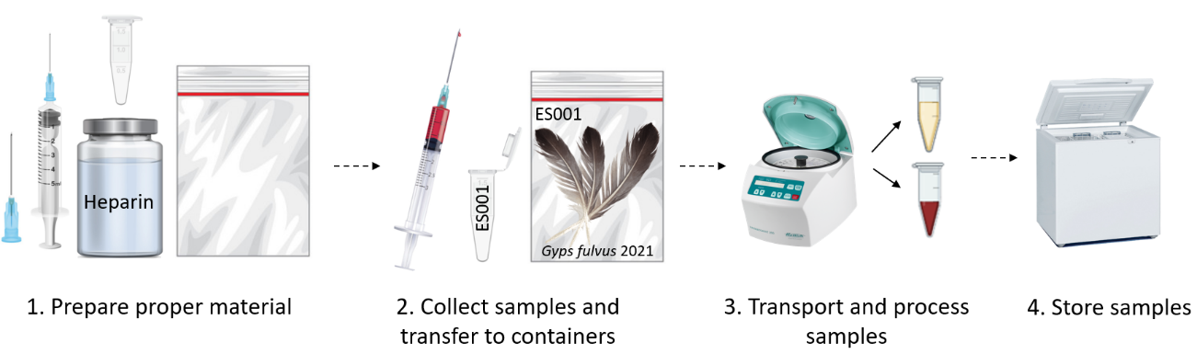
Fig. 1. Diagram of the brief protocol for blood and feather collection in vultures in the field.

Prepare the appropriate material:
Blood: Take blood samples using a hypodermic needle (e.g. 23G) and a syringe (e.g. 5 mL) (see Fig. 2a). Always change needles between individuals. Although blood volume should be sufficient to ensure analysis, the collection volume should not exceed 1% of the body weight. Prepare tubes depending on the volume collected (Fig. 2b). Use anticoagulants for whole blood/plasma collection (e.g. 2-3 drops of heparin in 1.5 ml-tubes or heparinized tubes; consider problems of EDTA for biochemistry and metal analyses and heparin for PCR analysis, more info: Espín et al., 2014). Handle the containers carefully to avoid contamination.
Feathers: Prepare sealed plastic bags or paper envelopes (Fig. 2c). Container materials should be checked to be free of contamination.
Eggs: Use suitable containers (e.g. polypropylene jars, chicken eggs boxes) to transport eggs and avoid breaking (Fig. 2d). Keep cool (about 4°C) and process egg as quickly as possible. Pieces of the eggshells found in the nest may be useful for some contaminant analysis and can be kept in sealed plastic bags.
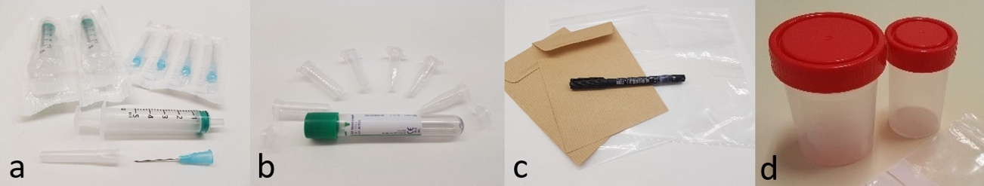
Fig. 2. (a) Hypodermic needle (23G) and syringe (5 mL), (b) polypropylene tubes for blood/plasma collection, (c) envelopes and sealed plastic bags for feathers, and (d) polypropylene jars for eggs.

Collect samples and transfer to proper container:
After recording the body measurements and wing-tagging the vulture (Fig. 3), prepare the bird for sampling. Cover the head with a cloth, avoid unnecessary noise and talking, and keep the handling time as short as possible. Use appropriate personal protective equipment and hold the bird with the help of additional personnel while collecting samples. Label the individual sample containers prior or immediately after the sample is collected. Each sample should have a unique code. A short and self-explanatory identification system that is easy to implement in the field should be used.

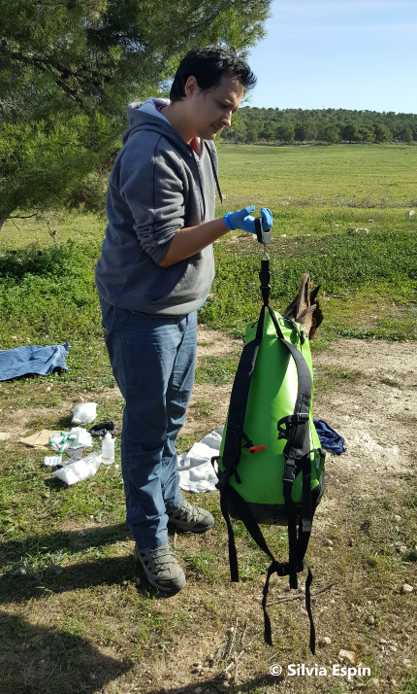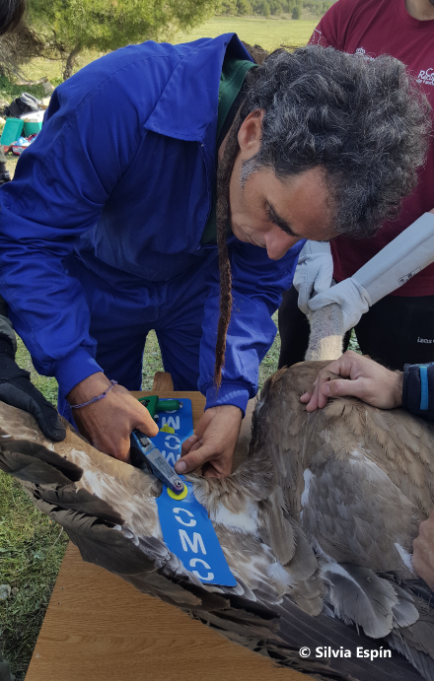
Fig. 3. Measuring body mass and wing-tagging of Griffon vulture (Gyps fulvus)

Blood: Collect blood from brachial vein (Fig. 4). Use antiseptic at the phlebotomy site and take blood samples puncturing the vein. Press the puncture site with sterile dry cloth before pulling the needle from the vein, and keep pressure for a few minutes to avoid bleeding and haematomas (more info: Espín et al., 2014, 2021). Remove needle before placing the sample in tubes. Tubes containing anticoagulants should be adequately filled in order to provide a proper blood-to-anticoagulant ratio. Rotate manually the tube gently to assure a homogeneous mix of blood-anticoagulant.
Feathers: Plucked back feathers are preferred (Fig. 4). Flight or tail feathers should not be collected to avoid impairment of flight ability. From dead birds, all feathers can be collected. Keep feathers in sealed plastic bags or paper envelopes.
Eggs: Collect only deserted eggs or addled eggs from the nest. Be careful about the timing of egg collection to avoid nest abandonment.
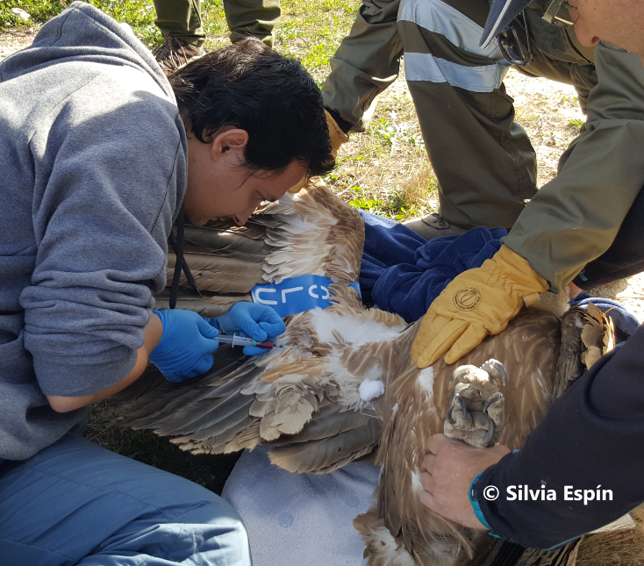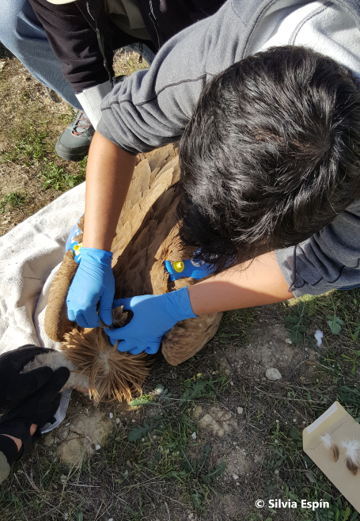
Fig. 4. Sampling blood and feathers from Griffon vulture (Gyps fulvus)

Transport to the laboratory and process sample:
Blood: Transport samples at 4-10°C. Avoid direct contact with cold blocks to avoid haemolysis. If plasma/serum is needed, centrifuge tube as soon as possible (1600-3000 g, 10 min), ideally within 6 hours after collection. Use anticoagulants in the tube to obtain plasma, otherwise you will obtain serum. Plasma/serum and red blood cells (RBC) separation is possible on fresh blood only and cannot be done on frozen samples. Use different pipette tips for each sample during plasma/serum separation to avoid cross contamination. Keep all separated fractions (plasma/serum and RBC) in different labelled tubes.
Feathers: Transport at ambient temperature or use cold blocks. Before they are stored, feathers should be cleaned of fresh tissue (blood, muscle) and they should be dried (if they are wet) when they are stored at ambient temperature. Alternatively, freeze the uncleaned feathers in sealed plastic bags. Identify type of the feather. In case of contour feathers, indicate the location on the body.
Eggs: Transport using cold blocks. Measure (length, width and weigh) and examine eggs before freezing. Open at the equator of the egg and empty its contents into flasks, weigh and homogenize the content (using clean tools), and keep frozen until analysis. Examine eggs for putrefaction, embryo development and deformities. If an embryo is present, keep frozen for future analyses. Rinse and dry eggshells at room temperature to measure eggshell thickness at equator using a caliper or micrometer. See details and pictures of the whole process in Espín et al. (2014, 2021).

Storage:
Blood: Keep frozen at -20°C /-80°C (depending on the compound/biomarker to be analyzed). Take advice from the laboratory undertaking the analysis.
Feathers: Feathers can be kept at room temperature if stored properly and if soft tissue or blood residue is removed. Store feathers in plastic sealed bags or envelopes, in darkness, and in a dry place if stored at room temperature. Alternatively, freeze the feathers in sealed plastic bags.
Eggs: Transfer egg content and eggshells to proper containers and store samples (homogenized content at -20°C and eggshells at room temperature).

Vultures specific field sampling protocol for passive biomonitoring in vultures

Note: Additional information on what contaminants are measured in different sample matrices and the relative merits of different samples for contaminant monitoring (addled and deserted eggs, feathers, blood, plasma, serum, internal tissues and other samples) can be found at Espín et al. 2016.

In Fig. 5 we present some contaminants or group of compounds of special relevance for vultures and the sample types frequently analyzed in biomonitoring studies (active monitoring of trapped lived birds and nests and passive monitoring of dead individuals).

SAI
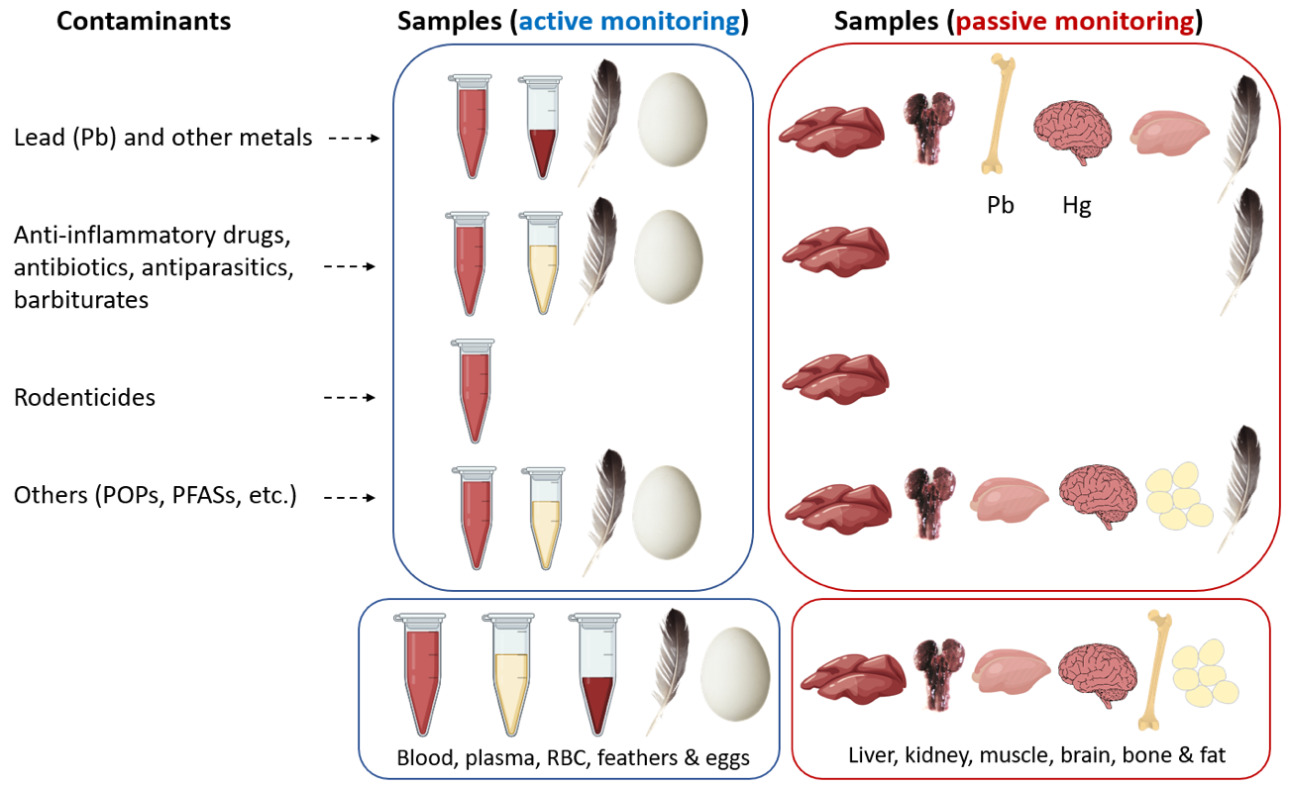

Fig. 5. Contaminants of special relevance for vultures and sample types frequently analyzed in biomonitoring studies (active monitoring of trapped lived birds and nests and passive monitoring of dead individuals). Please see Espín et al. (2016) for specific merits of each matrix for contaminant analyses.

Additional information on the volume and mass of sample needed for contaminant analyses, the type of container and transport conditions required for contaminant monitoring in different matrices is provided in Table 1 by Espín et al. (2021). Briefly, polypropylene (PP) tubes are recommended for blood, plasma, serum and RBC, and PP tubes and jars and sealed plastic bags are recommended for eggs and organs (Fig. 6). Both sealed plastic bags and envelopes can be used for feathers (Fig. 6). Although PP containers are recommended in general, glass could be considered if practical (note that some compounds varying from flame retardants to plasticisers could be in plastics and there could be potential contamination, so take advice from the laboratory and use field blanks when possible). Containers may be specifically precleaned for some contaminants (e.g. POPs, metals, perfluorinated; ask the laboratory).

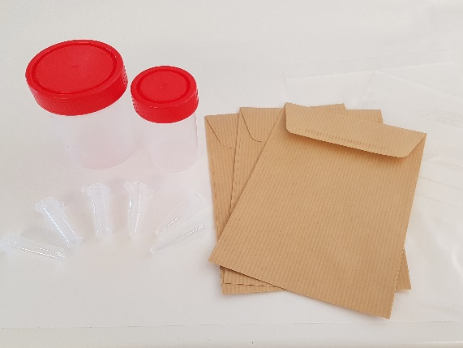

Fig. 6. Polypropylene tubes and jars, envelopes and sealed plastic bags.

Conclusion and recommendations

Useful links

· Visit ERBFacility Raptor Advice Hub – Section “How to collect samples” to visit the schematic and extended sampling protocols for contaminant monitoring in raptors and some guidance videos on sample collection and necropsy: provide link here
· Visit ERBFacility Raptor Advice Hub – Section “How to submit samples for analysis” for details on volume/mass of sample, type of container and transport conditions required for contaminant monitoring in different matrices, samples identification, and information on packaging, labelling, paperwork and legal considerations: provide link here
· Visit ERBFacility Raptor Advice Hub – Section “What can we analyse and where” to see details on what contaminants and biomarkers can be measured in different sample types (in both active and passive monitoring), the relative merits of different matrices for contaminant monitoring, and a list of laboratories with the services provided: link here
Visit ERBFacility Raptor Advice Hub – Section “How to share your monitoring data”: provide link here
Visit ERBFacility Raptor Advice Hub – Section “Information on legislation, permits, licensing, wildlife crime” to see the procedures to comply with the European and National legislation during raptor sampling (dead and living animals), and the international legislation and guidance on the collection and shipping of raptor samples: provide link here
Visit ERBFacility Raptor Advice Hub – Section “How to submit samples for analysis” for details on packaging, labelling, paperwork and legal considerations: provide link her
European Raptor Biomonitoring Facility (ERBFacility) COST Action (CA16224): https://erbfacility.eu/
Research and Monitoring for and with raptors in Europe (EURAPMON) – European Science Foundation: https://www.eurapmon.net/

References

Espín S, García-Fernández AJ, Herzke D, et al (2016) Tracking pan-continental trends in environmental contamination using sentinel raptors — what types of samples should we use? Ecotoxicology 25:777–801
Espín S, Martínez-López E, Jiménez P, et al (2014) Effects of heavy metals on biomarkers for oxidative stress in Griffon vulture (Gyps fulvus). Environ Res 129:59–68. https://doi.org/10.1016/j.envres.2013.11.008
García-Fernández AJ, Martinez-Lopez E, Romero D, et al (2005) High levels of blood lead in griffon vultures (Gyps fulvus) from Cazorla Natural Park (southern Spain). Environ Toxicol 20:459–463. https://doi.org/10.1002/tox.20132
Gómez-Ramírez P, Shore RF, van den Brink NW, et al (2014) The first inventory of existing raptor contaminant monitoring activities in Europe. Environ Int 67:12–21
Guitart R, Sachana M, Caloni F, et al (2010) Animal poisoning in Europe. Part 3: Wildlife. The Veterinary Journal 183:260–265. https://doi.org/10.1016/j.tvjl.2009.03.033
Margalida A, Bogliani G, Bowden CGR, et al (2014) One Health approach to use of veterinary pharmaceuticals. Science 346:1296–1298. https://doi.org/10.1126/science.1260260
Mateo R, Molina R, Grífols J, Guitart R (1997) Lead poisoning in a free ranging griffon vulture (Gyps fulvus). Vet Rec 140:47–48
Monclús L, Lopez-Bejar M, De la Puente J, et al (2018) First evaluation of the use of down feathers for monitoring persistent organic pollutants and organophosphate ester flame retardants: A pilot study using nestlings of the endangered cinereous vulture (Aegypius monachus). Environ Pollut 238:413–420. https://doi.org/10.1016/j.envpol.2018.03.065
Monclús L, Shore RF, Krone O (2020) Lead contamination in raptors in Europe: A systematic review and meta-analysis. Sci Total Environ 748:141437. https://doi.org/10.1016/j.scitotenv.2020.141437
Oaks JL, Gilbert M, Virani MZ, et al (2004) Diclofenac residues as the cause of vulture population decline in Pakistan. Nature 427:630–633. https://doi.org/10.1038/nature02317
Plaza PI, Martínez-López E, Lambertucci SA (2019) The perfect threat: Pesticides and vultures. Sci Total Environ 687:1207–1218. https://doi.org/10.1016/j.scitotenv.2019.06.160
References “Contaminates “
Aldeguer, M.P., Talavera, V., María-Mojica, P., Casaus, F., Bezunarpea, M., García-Fernández, A.J. 2009. Posibilidad de intoxicación por barbitúricos en aves carroñeras alimentadas con cadáveres de équidos eutanasiados con Dolethal®. [Possibility of barbiturate poisoning in scavengers fed carcasses of equidae euthanized with Dolethal®] XVIII Congreso Español de Toxicología. Rev. Toxicol. 26(1): 58.
Arrondo E, Navarro J, Pérez-García JM, Mateo R, Camarero P, Rodríguez M, Jiménez-Moreno M, Cortes-Avizanda A, Navas I, García-Fernández AJ, Sánchez-Zapata JA, Donázar JA. 2020. Dust and bullets: stable isotopes and GPS tracking disentangle lead sources for a large avian scavenger. Environ. Pollut. 266: 115022
Berny, P., Vilagines, L., Cugnasse, J.-M., Mastain, O., Chollet, J.-Y., Joncour, G., Razin, M., 2015. VIGILANCE POISON: Illegal poisoning and lead intoxication are the main factors affecting avian scavenger survival in the Pyrenees (France). Ecotoxicol. Environ. Saf. 118, 71–82. https://doi.org/10.1016/J.ECOENV.2015.04.003
Blanco, G., Junza, A., Barrón, D., 2017. Food safety in scavenger conservation: Diet-associated exposure to livestock pharmaceuticals and opportunist mycoses in threatened Cinereous and Egyptian vultures. Ecotoxicol. Environ. Saf. 135, 292–301. https://doi.org/10.1016/j.ecoenv.2016.10.009
Blanco, G., Junza, A., Segarra, D., Barbosa, J., Barrón, D., 2016. Wildlife contamination with fluoroquinolones from livestock: Widespread occurrence of enrofloxacin and marbofloxacin in vultures. Chemosphere 144, 1536–1543. https://doi.org/10.1016/j.chemosphere.2015.10.045
Espín; E. Martínez-López; P. Jiménez; P. María-Mojica; A.J. García-Fernández. 2015. Delta-aminolevulinic acid dehydratase (δALAD) activity in four free-living bird species exposed to different levels of lead under natural conditions. Environmental Research. 137, pp.185-198.
Espín; E. Martínez-López; P. Jiménez; P. María-Mojica; A.J. García-Fernández. 2014. Effects of heavy metals on biomarkers for oxidative stress in Griffon vulture (Gyps fulvus). Environmental Research. 129, pp.59-68.
García-Fernández, A.J. 2014. Ecotoxicology, Avian. In: Wexler, P. (ed) Encyclopedia of Toxicology, 3rd edition. vol 2. Elsevier Inc., Academic Press, pp. 289–294. ISBN: 9780123864543
García-Fernández, A.J., María-Mojica, P., Martínez-López, E., Romero, D., Navas, I., Hernández-García, A., Gómez-Ramírez, P. 2006. Aspectos clínicos y forenses del evenenamiento de aves silvestres: diferencias entre aldicarb y estricnina. Rev. Toxicol. 23: 44-48.
García-Fernández, A.J., Sánchez-García, J.A., Jiménez, P., Luna, A. 1995. Lead and cadmium in wild birds in southeastern Spain. Environ. Toxicol. Chem. 14:2049-2058.
García-Fernández, A.J., Martínez-López, E., Romero, D., María-Mojica, P., Godino, A., Jiménez, P. 2005. High Levels of Blood Lead in Vultures (Gyps fulvus) from “Cazorla” Natural Park (Southern Spain). Environ. Toxicol. 20: 459-463
Gómez-Ramírez, P., Blanco, G., García-Fernández, A.J., 2020. Validation of multi-residue method for quantification of antibiotics and NSAIDs in avian scavengers by using small amounts of plasma in HPLC-MS-TOF. Int. J. Environ. Res. Public Health 17, 4058. https://doi.org/10.3390/ijerph17114058
Gómez-Ramírez, P., Jiménez-Montalbán, P.J., Delgado, D., Martínez-López, E., María-Mojica, P., Godino, A., García-Fernández, A.J., 2018. Development of a QuEChERS method for simultaneous analysis of antibiotics in carcasses for supplementary feeding of endangered vultures. Sci. Total Environ. 626, 319–327. https://doi.org/10.1016/j.scitotenv.2018.01.060
Gupta, R.C. 1994. Carbofuran toxicity. J. Toxicol. Environ. Health 43: 383-418.
Gupta, R.C. 2014. Carbamate Pesticides. In: Wexler, P. (ed) Encyclopedia of Toxicology, 3rd edition. vol 1. Elsevier Inc., Academic Press, pp. 661–664. ISBN: 9780123864543
Henny, C.J., Kolbe, E.J., Hill, E.F., Blus, L.J., 1987. Case histories of bald eagles and other raptors killed by organophosphorus insecticides topically applied to livestock. J. Wildl. Dis. 23, 292–295. https://doi.org/10.7589/0090-3558-23.2.292
Herrero-Villar, M., Sánchez-Barbudo, I., Camarero, P.R., Mateo, R. 2021. Barbiturate Poisoning in Avian Scavengers and Other Predators in Spain. SETAC Europe 31st Annual Meeting, 3-6 May, Virtual Conference.
Kelly, T.R., Poppenga, R.H., Woods, L.A., Hernandez, Y.Z., Boyce, W.M., Samaniego, F.J., Torres, S.G., Johnson, C.K., 2014. Causes of mortality and unintentional poisoning in predatory and scavenging birds in California. Vet. Rec. Open 1, e000028. https://doi.org/10.1136/vropen-2014-000028
María-Mojica, P., Navas, I., Gómez-Ramírez, P Martínez-López, E., Espín, S., Jiménez, P., García-Fernández, A.J., 2018. Secondary poisoning by pentobarbital and flunixin in a vulture feeding station in Southeastern Spain, in: 39th SETAC North America Annual Meeting, Sacramento (CA, USA).
Mateo, R., Sánchez-Barbudo, I.S., Camarero, P.R., Martínez, J.M., 2015. Risk assessment of bearded vulture (Gypaetus barbatus) exposure to topical antiparasitics used in livestock within an ecotoxicovigilance framework. Sci. Total Environ. 536, 704–12. https://doi.org/10.1016/j.scitotenv.2015.07.109
Mineau, P., Fletcher, M.R., Glaser, L.C., Thomas, N.J., Brassard, C., Wilson, L.K., Elliott, J.E., Lyon, L.A., Henny, C.J., Bollinger, T., Porter, S.L., 1999. Poisoning of raptors with organophosphorus and carbamate pesticides with emphasis on Canada, U.S. and U.K. J. Raptor Res. 33, 1–37.
Naidoo, V., Wolter, K., Cromarty, D., Diekmann, M., Duncan, N., Meharg, A.A., Taggart, M.A., Venter, L., Cuthbert, R., 2010. Toxicity of non-steroidal anti-inflammatory drugs to Gyps vultures: a new threat from ketoprofen. Biol. Lett. 6, 339–41. https://doi.org/10.1098/rsbl.2009.0818
Pitarch, A., Gil, C., Blanco, G., 2017. Oral mycoses in avian scavengers exposed to antibiotics from livestock farming. Sci. Total Environ. 605–606, 139–146. https://doi.org/10.1016/j.scitotenv.2017.06.144
Plaza, P., Lambertucci, S.A. 2019. What do we know about lead contamination in wild vultures andcondors? A review of decades of research. Sci. Total Environ. 654: 409-417.
Rattner, B.A., Lazarus, R.S., Elliott, J.E., Shore, R.F., Van Den Brink, N., 2014. Adverse outcome pathway and risks of anticoagulant rodenticides to predatory wildlife. Environ. Sci. Technol. 48, 8433–8445. https://doi.org/10.1021/es501740n
Stone, W.B., Okoniewski, J.C., Stedelin, J.R., 2003. Anticoagulant Rodenticides and Raptors: Recent Findings from New York, 1998–2001. Bull. Environ. Contam. Toxicol. 70, 34–40.
Swan, G.E., Cuthbert, R., Quevedo, M., Green, R.E., Pain, D.J., Bartels, P., Cunningham, A.A., Duncan, N., Meharg, A.A., Oaks, J.L., Parry-Jones, J., Shultz, S., Taggart, M.A., Verdoorn, G., Wolter, K., 2006. Toxicity of diclofenac to Gyps vultures. Biol. Lett. 2, 279–282. https://doi.org/10.1098/rsbl.2005.0425
Thomas, P.J., Mineau, P., Shore, R.F., Champoux, L., Martin, P.A., Wilson, L.K., Fitzgerald, G., Elliott, J.E., 2011. Second generation anticoagulant rodenticides in predatory birds: Probabilistic characterisation of toxic liver concentrations and implications for predatory bird populations in Canada. Environ. Int. 37, 914–920. https://doi.org/10.1016/j.envint.2011.03.010
Zorrilla, I., Martinez, R., Taggart, M.A., Richards, N., 2015. Suspected flunixin poisoning of a wild Eurasian Griffon Vulture from Spain. Conserv. Biol. 29, 587–92. https://doi.org/10.1111/cobi.12417
Oaks, J. L., Gilbert, M., Virani, M. Z., Watson, R. T., Meteyer, C. U., Rideout, B. A., ... & Khan, A. A. (2004). Diclofenac residues as the cause of vulture population decline in Pakistan. Nature, 427(6975), 630-633.
Glossary

References sampling prtocols
Espín et al. 2014. Sampling and contaminant monitoring protocol for raptors. Research Networking Programme EURAPMON, Research and monitoring for and with raptors in Europe. Available at: http://www.eurapmon.net/results/contaminant-monitoring-protocol
Espín et al. 2016. Tracking pan-continental trends in environmental contamination using sentinel raptors-what types of samples should we use? Ecotoxicology 25(4): 777-801.
Espín et al. 2021. A schematic sampling protocol for contaminant monitoring in raptors. Ambio 50, 95-100. Available as Supplementary Material here: https://link.springer.com/article/10.1007/s13280-020-01341-9

