**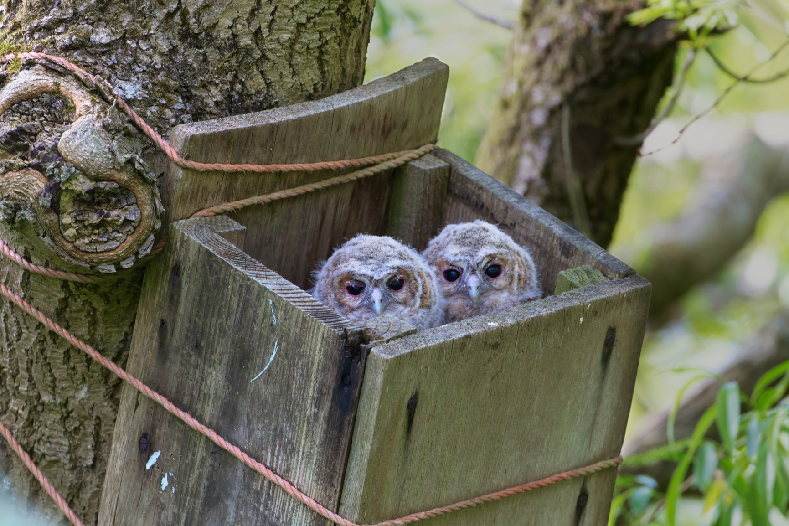**

Photo © Edmund Fellowes/BTO Images

**ERBFacility**

**EUROPEAN RAPTOR BIOMONITORING FACILITY**

COST ACTION 16224

**WG4 & cross-WG Virtual Workshop**

**13-15 October 2020**

**TAKING FORWARD GOOD PRACTICE GUIDANCE, THE PROOF OF CONCEPT STUDY & PLANNING FOR THE FUTURE OF THE NETWORK**

Hosted by Chris Wernham (BTO Scotland) & the ERBFacility WG4 Team

**PROGRAMME**

This event is organised by COST 16224 Action European Raptor Biomonitoring Facility and supported by COST (European Cooperation in Science and Technology)

****COST (European Cooperation in Science and Technology) is a pan-European intergovernmental framework. Its mission is to enable break-through scientific and technological developments leading to new concepts and products and thereby contribute to strengthening Europe’s research and innovation capacities. [www.cost.eu](http://www.cost.eu).

EU-FLAG_cmyk_CS3.epsCOST is supported by the EU Framework Programme Horizon 2020.

**Organising Committee:**

Chris Wernham (Lead WG4)

Rui Lourenço (Deputy Lead, WG4)

Al Vrezec (Vice Chair of ERBFacility & WG4 Team)

Jovan Andevski (WG4 Team)

Arianna Aradis (WG4 Team)

Yael Choresh (WG4 Team)

Ulf Johansson (WG4 Team)

Stavros Xirouchakis (WG4 Team)

Silvia Espín (WG4 Team)

Pablo Sánchez Virosta (WG4 Team)

András Kovács (WG4 Team)

Rafa Mateo (Lead for Proof of Concept Study)

Guy Duke (Chair, ERBFacility)

**WORKSHOP OBJECTIVES**

This workshop is convened by Working Group 4 (‘Field Arena’) to help us deliver our work plan and over-arching objectives specified in the COST Action and to assist the Core Group with planning the future deliverables of the Action and the project legacy (see <https://erbfacility.eu/>).

The specific objectives of this workshop will be:

1. To plan the tasks for finalising the ERBF Advice Hub and carry out as much of the writing to complete the sections as possible.
2. To complete the ERBF good practice guidance for vultures.
3. To discuss and agree the next steps in delivery of the ERBF Proof of Concept study and how to find the resources to deliver the work in a suitable timeframe.
4. To ‘brain-storm’ the linkages between the different working groups towards a blue-print for any future ERBF, the deliverables from our COST Action, and to start to plan for the legacy of the project.

The workshop aims to produce the following outputs:

1. An updated Advice Hub document that is nearing completion, with a clear plan and timeline for how to complete the drafting (this is in preparation for asking for wider input to the Advice Hub at a wider ERBF workshop in early 2021)
2. A near-complete version of the specific good practice guidance for vultures, again with a clear plan and timeframe for completion of the work.
3. A clear updated plan and timeline for the Proof of Concept study, solutions to any current constraints on delivery and suggestions to solve resourcing issues.
4. A draft planning document on how the 3 parts of the ERBF – the biomonitoring scheme (ERBioMS); the specimen bank (ERSpecB); and the Sampling programme (ERSamP) – with be linked together, and draft ideas for the nature of deliverables that we will produce on this.
5. A first set of considerations and suggestions for leaving an appropriate project legacy – how might we sustain our network after the end of the COST Action and move further towards a functional ERBFacility in future?

**DRAFT PROGRAMME SCHEDULE**

|  |  |  |
| --- | --- | --- |
| **Time slot (CEST)** | **Activities** | **Lead and assistants / notes** |
|  |  |  |
| *Tuesday 13 October* |  |  |
| 09:00 – 09:30 | **Connect to Zoom to test if you have not used it before** | Chris |
| 09:30 – 10:00 | Welcome, time to join and check connections, outline plan for the workshop | Chris |
| **10:00 – 11:00** | **SESSION 1 – Introductory sessions** | Chris to Chair (PLENARY) |
| 10:00 – 10:20 | TOPIC 1 - Advice Hub work – presentation and suggestions from everyone | Silvia, Pablo & Chris (monitoring section) (PLENARY) |
| 10:20 – 10:40 | TOPIC 2 - Vulture guidance work - presentation and suggestions from everyone | Jovan (PLENARY) |
| 10:40 – 11:00 | Split for group work on TOPIC 1 & TOPIC 2 | Break-out groups – TOPIC 1 & TOPIC 2 |
| **11:00 – 11:30** | **COFFEE BREAK & SOCIAL** | PLENARY |
| 11:30 – 13:00 | Split for group work on TOPIC 1 & TOPIC 2 | Break-out groups – TOPIC 1 & TOPIC 2 |
| 13:00 – 14:30 | LONG LUNCH BREAK |  |
| 14:30 – 16:00 | **SESSION 2 – Proof of Concept study** |  |
| 14:30 – 15:00 | Update on TOPIC 3 - Proof of Concept study - and questions to be addressed | Rafa & Rui (PLENARY) |
| 15:00 – 16:00 | Split for group work on TOPIC 3 (or more work on TOPICs 1 & 2 for those not involved in TOPIC 3) | Break-out groups – TOPIC 3 (one or more groups) plus TOPIC 1 & TOPIC 2 |
| 16:00 – 16:30 | COFFEE BREAK & SOCIAL |  |
| 16:30 – 17:30 | Split for group work on TOPIC 3 (or more work on TOPICs 1 & 2 for those not involved in TOPIC 3) | Break-out groups – TOPIC 3 (one or more groups) plus TOPIC 1 & TOPIC 2 |
| 17:30 – 18:00 | SUMMARY OF THE DAY & PLAN FOR DAY 2 | Chris and topic leads (PLENARY) |
|  |  |  |
| *Wednesday 14 October* |  |  |
| 09:30 – 10:00 | Welcome and plan for the day | Chris and topic leads (PLENARY) |
| 10:00 – 13:00 | **Session 3 – More work in groups or alone on TOPIC 1, TOPIC 2 & TOPIC 3** |  |
| 10:00 – 11:00 | More work in groups or alone on TOPIC 1, TOPIC 2 & TOPIC 3 | Break-out groups – TOPIC 3 (one or more groups) plus TOPIC 1 & TOPIC 2 |
| 11:00 – 11:30 | COFFEE BREAK & SOCIAL |  |
| 11:30 – 13:00 | More work in groups or alone on TOPIC 1, TOPIC 2 & TOPIC 3 | Break-out groups – TOPIC 3 (one or more groups) plus TOPIC 1 & TOPIC 2 |
| 13:00 – 14:30 | LUNCH & SOCIAL |  |
|  |  |  |
| 14:30 – 16:00 | **Session 4 – More work on Proof of Concept (or more work on TOPICs 1 & 2 for those not involved in TOPIC 3)** | Rafa & Rui (PLENARY OR GROUPS AS REQUIRED) |
| 16:30 – 17:00 | COFFEE & SOCIAL |  |
| 17:00 – 18:00 | FEEDBACK ON PROGRESS & PLANS FOR DAY 3 | Chris and topic leads |
|  |  |  |
| *Thursday 15 October* |  |  |
| 09:30 – 10:00 | Welcome and plans for the final day | Chris |
| 10 – 12:30 | **Session 5 - More work in groups or alone on TOPIC 1, TOPIC 2 & TOPIC 3** | Break-out groups – TOPIC 3 (one or more groups) plus TOPIC 1 & TOPIC 2 |
| 12:30 – 14:00 | LUNCH & SOCIAL |  |
| 14:00 – 16:30 | **Session 6 – Linkages between the WGs (TOPIC 4) and project legacy (TOPIC 5)** | Guy (with any help required) PLENARY and group work if needed |
| 16:30 – 17:00 | COFFEE & SOCIAL |  |
| 17:00 – 18:00 | SUMMARY, NEXT STEPS, PLANS FOR REPORTING & CLOSE | Chris and topic leads |
| 18:00 | WORKSHOP CLOSE |  |

**TOPIC LEADS**

**Topic 1 – Advice Hub – Silvia & Pablo (most topics) + Chris (monitoring)**

**Topic 2 – Vulture guidance - Jovan**

**Topic 3 – Proof of Concept – Rafa & Rui**

**Topic 4 – Cross-WG framework (bringing together the ERBF ‘blue-print’ – ERBioMS; ERSpecB; ERSamP) - Guy**

**Topic 5 – Planning for an ERBFacility project legacy - Guy**

**PRACTICALITIES**

The meeting with be hosted in Zoom (more details below). We would like everyone to dedicate as much of the 3 days as possible to ERBFacility work, just as you would if you travelled to a workshop. We will try to make it as much like a face-to-face workshop as we can, by including sessions at coffee times and at lunchtimes when we can socialise and catch up personally, as well as a chance to network about work. **So please try to have your lunch, coffee and snacks available easily so that you can join some socialisation during breaks.**

* We will start the workshop at 09:30 CEST each day but the Zoom link will be available from 09:00 if you want to join early and test your computer link.
* Please try to have access to a good microphone (ideally use a headset with a microphone) and a web cam so that we can see you if at all possible.
* If you have not used Zoom before, please try to join early (09:00 CEST) on Tuesday 13 October so that we can help you to connect successfully. If you have problems, please e-mail Chris ([chris.wernham@bto.org](mailto:chris.wernham@bto.org)) and we will do all we can to help.
* At the start of the workshop, we will explain how to use the different functions in Zoom (very simple) and some tips for making virtual meetings work effectively. We will also explain how we will use ‘break-out rooms’ for some of our working sessions.
* **The most important tip is to please make sure you can mute your microphone when you are not speaking, as this will ensure we have good sound quality for those that are speaking and that background noise does not disturb the meeting.**

Zoom links for the workshop

*Tuesday 13 October*

Topic: ERBF Virtual Workshop - Day 1

Time: Oct 13, 2020 09:00 CEST

Join Zoom Meeting

[**https://zoom.us/j/97133437500?pwd=ZnovQTNXenVGYzh6Uys1R0hWWnlwUT09**](https://zoom.us/j/97133437500?pwd=ZnovQTNXenVGYzh6Uys1R0hWWnlwUT09)

Meeting ID: 971 3343 7500

Passcode: 651756

*Wednesday 14 October*

Topic: ERBF Virtual Workshop - Day 2

Time: Oct 14, 2020 09:00 CEST

Join Zoom Meeting

[**https://zoom.us/j/97839677764?pwd=alEvSHVLcXNWWEVQZUltNkNUc3E0QT09**](https://zoom.us/j/97839677764?pwd=alEvSHVLcXNWWEVQZUltNkNUc3E0QT09)

Meeting ID: 978 3967 7764

Passcode: 818616

*Thursday 15 October*

Topic: ERBF Virtual Workshop - Day 3

Time: Oct 15, 2020 09:00 CEST

Join Zoom Meeting

[**https://zoom.us/j/92478187682?pwd=TmFXRXI0cUlGSzhMUmNtVHpVUExtdz09**](https://zoom.us/j/92478187682?pwd=TmFXRXI0cUlGSzhMUmNtVHpVUExtdz09)

Meeting ID: 924 7818 7682

Passcode: 957498