**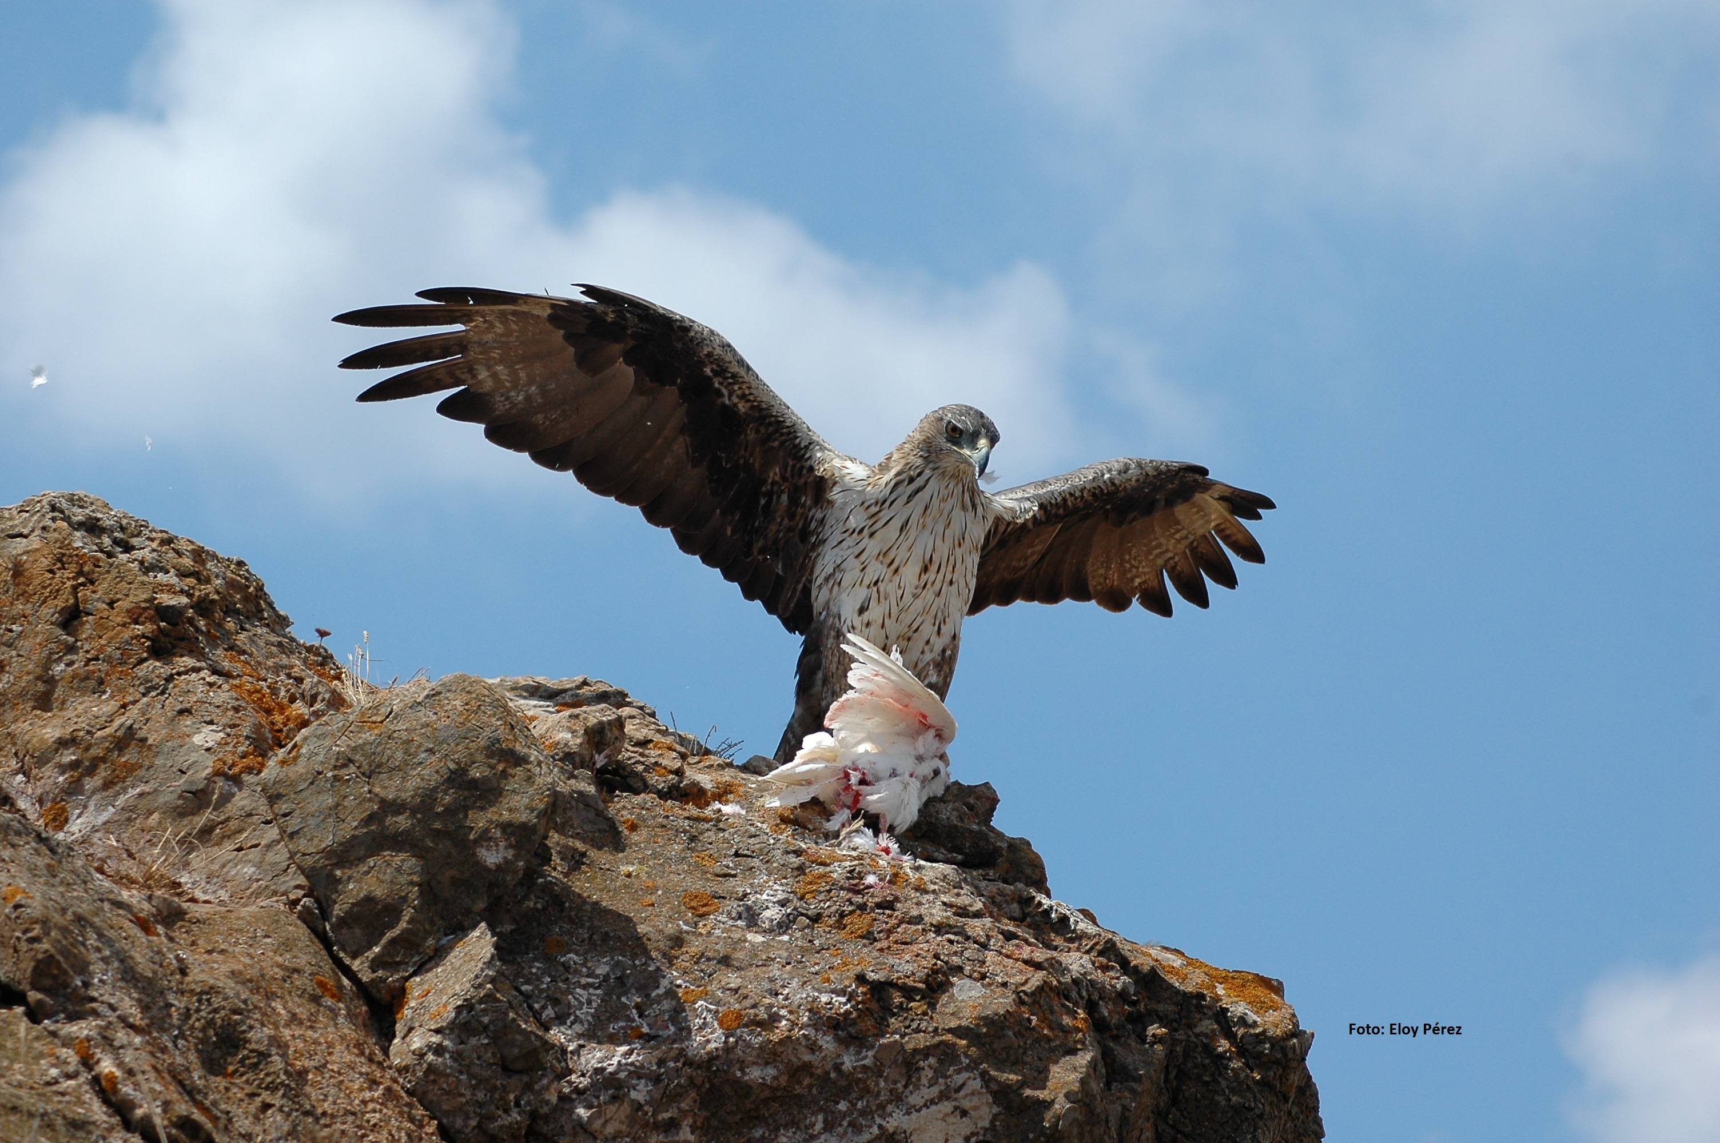**

Photo Eloy Pérez

**ERBFacility**

**EUROPEAN RAPTOR BIOMONITORING FACILITY**

COST ACTION 16224

**WG1&2 Virtual Workshop**

***10-11 December* 2020**

***QUALITY ASSURANCE, STANDARDISATION AND HARMONIZATION OF ANALYTICAL TECHNIQUES FOR PAN-EUROPEAN RAPTOR BIOMONITORING AND APPLICATION TO THE PROOF OF CONCEPT***

Hosted by Lee Walker (CEH, UK), Antonio García-Fernández (UM, ES)

& the ERBFacility WG1&2 Teams

**PROGRAMME**

This event is organised by COST 16224 Action European Raptor Biomonitoring Facility and supported by COST (European Cooperation in Science and Technology)

****COST (European Cooperation in Science and Technology) is a pan-European intergovernmental framework. Its mission is to enable break-through scientific and technological developments leading to new concepts and products and thereby contribute to strengthening Europe’s research and innovation capacities. [www.cost.eu](http://www.cost.eu).

EU-FLAG_cmyk_CS3.epsCOST is supported by the EU Framework Programme Horizon 2020.

**Organising Committee:**

Lee Walker (Lead WG1)

Antonio J. García-Fernández (Lead WG2 and Scientific Grant Holder)

Pablo Sánchez-Virosta (WG1&2 Team and Administrative Grant Holder)

Rafael Mateo (WG1&2 Team and Lead of Proof of Concept Study)

Oliver Krone (WG1&2 Team and STSM coordinator)

Madis Leivits (WG1&2 Team and Communication coordinator)

Silvia Espín (WG1&2 Team)

Pilar Gómez-Ramírez (WG1&2 Team)

Irene Valverde (W1&2 Team)

Igor Eulaers (WG1&2 Team)

Veerle Jaspers (WG1&2 Team)

Philippe Berny (WG1&2 Team)

Ana López Antia (WG1&2 Team)

**WORKSHOP OBJECTIVES**

This workshop is convened by Working Groups 1&2 (‘Analysis Arena’) to help us deliver our work plan and over-arching objectives specified in the COST Action and to assist the Core Group with planning the future deliverables of the Action and the project legacy (see <https://erbfacility.eu/>).

**The specific objectives of this workshop will be:**

1. To discuss and agree the list of laboratories available to participate in the Proof of Concept.
2. To discuss and agree on quality assurance of the analytical methods used by the different laboratories selected for the Proof of Concept.
3. To discuss and agree parameters for standardisation and harmonization of analytical techniques for the Proof of Concept.
4. To discuss and agree on the list of laboratories for the Advice Hub.

**The workshop aims to produce the following outputs:**

1. A definitive list of laboratories selected to participate in the Proof of Concept.
2. A clear updated plan of delivery and timeline for the analysis included in the Proof of Concept study.
3. A clear agreement of the requirements that laboratories should adhere to in terms of the quality assurance of their analytical techniques in raptor sample matrices.
4. The list of laboratories to be included in the Advice Hub and to be uploaded to the ERBFacility webpage.

**TOPIC LEADS**

**Topic 1 – Proof of Concept for Analysis Arena – Rafael Mateo & Lee Walker**

**Topic 2 – Potential laboratories to participate in Proof of Concept – Pilar Gómez-Ramírez**

**Topic 3a – Strengths and weaknesses of each approach for each analyte – Lee Walker**

**Topic 3b – Standardisation and harmonization of interlaboratory QA/QC for PoC – Pilar Gómez & Antonio García**

**Topic 4 – Approaches to interpret and present the results of the PoC – Ana López-Antia & Oliver Krone**

**Topic 5 – Laboratories for Advice Hub – Silvia Espín & Antonio García-Fernández**

**PROGRAMME SCHEDULE**

|  |  |  |  |
| --- | --- | --- | --- |
| **Time slot (CEST)** | **Activities** | | **Lead and assistants / notes** |
| *Thursday 10 December* | |  |  |
| 09:00 – 09:30 | **Connect to Zoom to test your settings** | |  |
| 09:30 – 10:00 | Welcome and workshop outline and aims | | Lee & Antonio |
|  |  | |  |
| **10:00 – 11:00** | **SESSION 1 – Plenary sessions** | |  |
| 10:00 – 10:20 | **TOPIC 1 – Proof of Concept for Analysis Arena** | | Rafa & Lee |
| 10:20 – 10:40 | **TOPIC 2 – Potential laboratories to participate in Proof of Concept** | | Pilar |
| 10:40 – 11:00 | Group work on TOPIC 1 & TOPIC 2 | | Break-out groups |
|  |  | |  |
| 11:00 – 11:30 | COFFEE BREAK & SOCIAL | | PLENARY |
|  |  | |  |
| 11:30 – 12:30 | Group work on TOPIC 1 & TOPIC 2 | | Break-out groups |
| 12:30 – 13:00 | Feedback from break-out groups | | PLENARY with rapporteurs |
|  |  | |  |
| 13:00 – 14:30 | LUNCH & SOCIAL | |  |
|  |  | |  |
| **14:30 – 18:00** | **SESSION 2 – Standardisation and harmonization of Quality Assurance techniques** | | Lee & Pilar |
| 14:30 – 14:45 | **TOPIC 3a – Strengths and weaknesses of the technique and QA measures for each analyte** | | Lee |
| 14:45 – 15:00 | **TOPIC 3b – Standardisation and harmoniza-tion of interlaboratory QA/QC for PoC** | | Pilar & Antonio |
| 15:00 – 16:00 | Group work on:  **(a) inter-laboratory assays (b) QA measures to be reported** | | Break-out groups |
|  |  | |  |
| 16:15 – 16:45 | COFFEE BREAK & SOCIAL | | PLENARY |
|  |  | |  |
| 16:45 – 17:45 | Feedback from break-out groups | | PLENARY with rapporteurs |
| **17:45 – 18:00** | SUMMARY OF THE DAY & PLAN FOR DAY 2 | | Lee, Antonio and topic leads |

|  |  |  |  |
| --- | --- | --- | --- |
| **Time slot (CEST)** | **Activities** | | **Lead and assistants / notes** |
| *Friday 11 December* | |  |  |
| 09:30 – 10:00 | Welcome and plan for the day | | Lee, Antonio and topic leads |
|  |  | |  |
| **10:00 – 13:00** | **SESSION 3 – Presentation of results and Advice Hub** | |  |
| 10:00 – 10:25 | **TOPIC 4 – Approaches to interpret and present the results of the PoC**  10 min presentation each & 5 min Questions | | Ana & Oliver |
| 10:25 – 11:00 | Group work on:  **(a) metals**  **(b) rodenticides** | | Break-out groups |
|  |  | |  |
| 11:00 – 11:30 | COFFEE BREAK & SOCIAL | | PLENARY |
|  |  | |  |
| 11:30 – 12:00 | Group work on:  **(a) metals**  **(b) rodenticides** | | Break-out groups |
| 12:00 – 12:20 | Feedback from break-out groups | | PLENARY with rapporteurs |
| 12:20 – 13:00 | **TOPIC 5 – Laboratories for Advice Hub**  10 min presentation & 5 min Questions  25 min discussion | | Silvia & Antonio |
|  |  | |  |
| 13:00 – 14:00 | LUNCH & SOCIAL | | PLENARY |
|  |  | |  |
| **14:00– 15:30** | **Next steps**  STSMs  Others items to be confirmed | | Lee & Antonio |
|  |  | |  |
| 15:30 – 16:00 | COFFEE & SOCIAL | | PLENARY |
|  |  | |  |
| **16:00 – 16:30** | **Concluding remarks** | | Lee, Antonio and topic leads |

**PRACTICALITIES**

The meeting with be hosted in Zoom (more details below). We would like everyone to dedicate as much of the 2 days as possible to ERBFacility work, just as you would if you travelled to a workshop. We will try to make it as much like a face-to-face workshop as we can, by including sessions at coffee times and at lunch times when we can socialise and catch up personally, as well as a chance to network.

* We will start the workshop at 09:30 CEST each day but the Zoom link will be available from 09:00 if you want to join early and test your computer settings.
* Please try to have access to a good microphone (ideally use a headset with a microphone) and a web cam so that we can see you if at all possible.
* If you have not used Zoom before, please try to join early (09:00 CEST) on Thursday 10 December so that we can help you to connect successfully. If you have problems, please e-mail Pablo ([pablo.s.v@um.es](mailto:pablo.s.v@um.es)), Lee ([leew@ceh.ac.uk](mailto:leew@ceh.ac.uk)) or Antonio ([ajgf@um.es](mailto:chris.wernham@bto.org)) and we will do all we can to help.
* At the start of the workshop, we will explain how to use the different functions in Zoom (very simple) and some tips for making virtual meetings work effectively. We will also explain how we will use ‘break-out rooms’ for some of our working sessions.
* **The most important tip is to please make sure you can mute your microphone when you are not speaking, as this will ensure we have good sound quality for those that are speaking and that background noise does not disturb the meeting.**

**Zoom links for the workshop**

*Thursday 10 December*

Topic: ERBFacility WG 1&2 Workshop- Day 1

Time: Dec 10 (Thursday), 2020 09:00 CEST

Join Zoom Meeting

[https://umurcia.zoom.us/j/97935250610?pwd=dWIra3FUMklOSHI1bnlySTBBb012QT09](https://umurcia.zoom.us/j/97935250610?pwd=dWIra3FUMklOSHI1bnlySTBBb012QT09" \t "_blank)

Meeting ID: 979 3525 0610

Passcode: 720126

*Friday 11 December*

Topic: ERBFacility WG 1&2. - Day 2

Time: Dec 11 (Friday), 2020 09:00 CEST

Join Zoom Meeting

[https://umurcia.zoom.us/j/96154828824?pwd=eGYrZkRzdk42Um9sdlMxL0xqS0RqQT09](https://umurcia.zoom.us/j/96154828824?pwd=eGYrZkRzdk42Um9sdlMxL0xqS0RqQT09" \t "_blank)

Meeting ID: 961 5482 8824

Passcode: 540991